Title of article (CZECH)

Title of article (English)

Author 1

Company, address, author’s contacts, www

Author 2

Company, address, author’s contacts, www

Abstract

This document is template for preparing paper to proceedings of colloquium “Reinforcement, Sealing and Bolting of Rock Mass and Engineering Construction 2018”. Document is prepared as template (.dotx) for Microsoft Word 2013 and includes predefined styles for text formatting. This sample text is created using these styles thus can be used for direct editing of text.

For abstract Times New Roman, italics, 12 pts (English language is used. Recommended length of abstract is 100 – 120 words (8 lines).

1. Formal requirements for paper preparation

Basic design of page respects A4 format, border settings: top 2,5 cm, bottom 2,5 cm, left 2,5 cm, right 2,5 cm.

Basic font of paper is Times New Roman, 12 pts. Simple line spacing, text alignment to block (both sides). Spacing before and after paragraph is 6 pts. If needed to highlight part of text, use underline.

For Chapter heading (Level 1) Times New Roman bold, 12pts, all capitals, spacing before paragraph 25 pts. In case of multi-level chaptering (up to 4 levels) predefined styles can be used including automated numbering and text formatting. More details on individual chapters see Chapter 2 – Structuring of paper.

1. structuring of paper – heading level 1
   1. Heading Level 2 – Times New Roman bold 12 pts, spacing before paragraph 10 pts.
      1. Heading Level 3 – Times New Roman bolt italics 12 pts, spacing before paragraph 10 pts
         1. Heading Level 4 – Times New Roman italics underline 12 pts, spacing before paragraph 10 pts
2. picture and table insertion, using bullets
   1. Inserting picture into text

Picture is inserted as centered. Position of heading below picture, used font Times New Roman italics 10 pts, centered, spacing before paragraph 10 pts. In case of need it is possible to place more pictures one next to each other but only that sufficient clarity and illustrative is maintained.

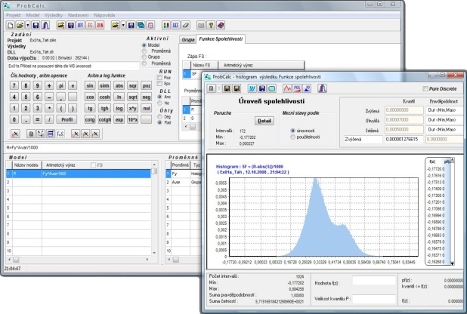

Fig. 1 Sample of picture heading



Fig. 2, 3 Samples of picture heading

* 1. Inserting tables to text

Table is inserted into text with alignment to left. Description is positioned below table, Times New Roman 12 pts, alignment left, spacing before and after paragraph 10 pts and 6 pts. Below table keep one line empty.

Tab.1: Table title

|  |  |  |  |  |
| --- | --- | --- | --- | --- |
| Variable | UoM | Type of distribution | Parameters | |
| Mean value | Standard deviation |
| The amplitude of stress peaks | [MPa] | Normal | 30 | 2 |
|  |  |  |  |  |
|  |  |  |  |  |

* 1. Using bullets and lists

Use bellow mentioned sample for formatting of text in bullets or numbered lists. In both cases formatting is the same - Times New Roman 12 pts, alignment left, first line indent 0,63 cm, spacing before and after paragraph 0 pts.

* Bullet
* Bullet

1. Numbered list
2. Numbered list

Literature

1. AUTHOR, A. B. Publication title. 1st ed. Praha : SNTL, 1995. 250 pp. ISBN 1-234-568-787.
2. AUTHOR, C. & AUTHOR, D. Contribution title. Journal name. 2005, XXVI. Nr. 2, pp. 56-58. ISSN 1234-5678.
3. AUTHOR, E. Paper title. In Proceedings name. Place : Company name, 1989, pp. 156-158. ISBN 12-34-567-89.
4. AUTHOR, F. Paper title. Transactions of the VŠB – Technical University of Ostrava, Civil Engineering Series. Volume 15, Issue 1, Pages 1–10, ISSN (Online) 1804-4824, DOI: 10.1515/tvsb-2015-0001, July 2015.