VSB - Technical University of Ostrava
(Vysoká Škola Báňská-technická Univerzita Ostrava)
Faculty of Civil Engineering
Department of Architecture
Building Typology, Practical Theory

Libraries
Typology, Concepts Evolution and Characteristics
In Historical Context

Prof. Ing. arch. Petr Hrůša
Ing. arch. Klára Palánová, Ph.D.
Submitted by/
BCs. Khaled Khalil Yehia
Table of Contents

Table of Contents 2
Table of Figures 3
Introduction 4
The Basic Concepts of Libraries 4
Typological Types of Libraries
(National Libraries) 5
(Public Libraries) 6
(School Libraries) 6
(Special Libraries) 7
(Archives) 7
(Private Libraries) 8
(Subscription Libraries) 8
Historical Typological & Development, Principles and Characteristics of Libraries in History
Libraries in Antiquity (Eastern Libraries) 9
Greek Libraries (Pergamum) 10
Ancient Egypt Libraries 10
Roman Libraries 11
Byzantine Libraries 11
Islamic Libraries 12
Libraries of Europe in the Medieval & the Renaissance 12
Europe Libraries in the Modern Ages 13
Current Libraries Typological Situation & Designs in Europe and Czech Republic
Central Library Oodi in Helsinki, Finland 14
Realization Examples of Libraries in Czech Republic
The National Library of Czech Republic, Prague 15
The Futuristic Blob National Library of Czech Republic 16
Sources 17

Table of Figures
Fig 1. The Architecture Plan & Elevation of Bibliothèque Nationale de France 5
Fig 2. Spaces Analytical Floor Plan for the middle part of the Bibliothèque nationale de France 5
Fig 3. Puebla, Mexico: Palafox Library. Illustration of 1773 by Miguel Jerónimo Zendejas 6
Fig 4. The Library of Parliament in Ontario, Canada. Cross-Section 7
Fig 5. The Library of Parliament in Ontario, Canada built in the Gothic revival architectural style. 7
Fig 6. The National Archives History Office preserves and promotes the history of the National Archives. 7
Fig 7. Library of Ashurbanipal Mesopotamia 1500-539 BC Gallery, British Museum, London, England, UK 8
Fig 9. The Library Company of Philadelphia, founded by Benjamin Franklin in 1731 8
Fig 10. The Plan of Assyrian Palace 9
Fig 11. Illustration of Ancient Assyrian Palace. 9
Fig. 12 Isometric Illustration for the Library of Pergamum 10
Fig. 13 Plan of the Library of Pergamum 10
Fig. 14 Illustration for The Royal Library of Alexandria, 3rd century BC, Alexandria, Egypt 10
Figure. 15 Bath of Trajan plan 11
Figure. 16 The library’s plan of Trajan’s Path 11
Fig. 17 Floor plans and Elevations of St Marks Library, Venice, Italy 11
Fig 18. Illustration for the Library of the Islamic House of Wisdom 12
Fig 19. The Laurentian Library Plan and Elevation of Michelangelo 12
Fig 20. The Laurentian Library Staircase 12
Fig 21. Plans and Section of the British Museum & Library 13
Figure 22. Cross-Section of the Oodi Library Building 14
Figure 23. Schematic drawings of the ground, second and third floors. Images courtesy of ALA Architects 14
Figure 24. The floor plan of Prague’s Klementinum Library. 15
Figure 25. The whole floor plan of Prague’s Klementinum. The library 15
Figure 26. The interior of the Klementinum Baroque Library Hall 15
Figure 27. The interior of the Klementinum Baroque Library Hall 15
Fig 28. Structural Layers of the Library 16
Fig 29. Isometric Cross-Section of the Blob Structure 16
Fig 30. 2D Section of the Library 16

Introduction
The definition term of library
The traditional definition of a library is a “collection of books of different types that could be used for reading or study”, library’s term can also be for the building or room in which this collection is kept”.

Libraries may also have manuscripts, journals, and other sources of recorded information. They commonly include reference works, such as encyclopedias that provide factual information and indexes that help users find information in other sources; creative works, including poetry, novels, short stories, music scores, and photographs; nonfiction, such as biographies, histories, and other factual reports; and periodical publications, including magazines, scholarly journals, and books published as part of a series.
After the invention of the computer and, since technology has started to develop, libraries started to have different forms of information such as audiotapes and videotapes and other forms of media. [1]
The term “library”
The word derives from the Latin liber, “book,” whereas a Latinized Greek word, bibliotheca, is the origin of the word for library in German, Russian, and the Romance languages.
From their historical beginnings as places to keep the business, legal, historical, and religious records of a civilization. [1]
The basic concepts of libraries
Libraries were and still are the gate for every civilization to be the witness on its history. Every civilization has its own architectural characteristics, this may be reflected on the different architecture style, design and typology of Libraries.
libraries witnessed the development of the Architecture History since, all civilizations tried and are still trying to store its own history in books or buildings with different books collections which are called “Libraries”, through the chronological different eras and civilizations that began from Antiquity and Eastern civilization, until the currently history.
The style, typology and architecture design of Libraries vary depending on the time at which they were established, the possibilities, resources and events were the most influential factors of libraries throughout the consecutive civilizations, starting from stones, papers, walls in antiquity, passing by the dominance of Libraries buildings, till the modern libraries in the modernity since the middle of the 20th century that libraries became a life necessity which have emerged so far that It could reach everybody and be able to provide all kinds of information resources and services without having to even require a building.

- National Libraries
- School Libraries
- Public Libraries
- Subscription Libraries

- Archives
- Private Libraries
- Special Libraries

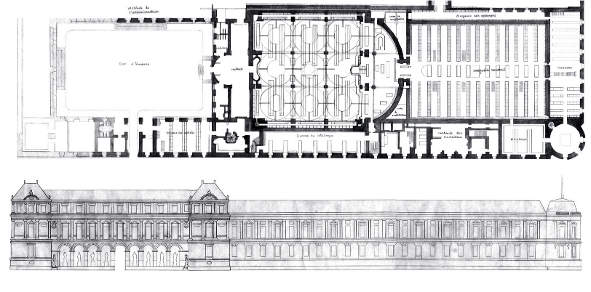
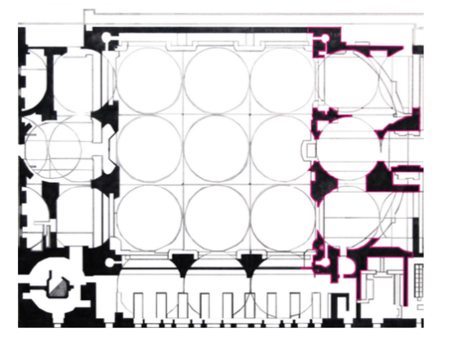
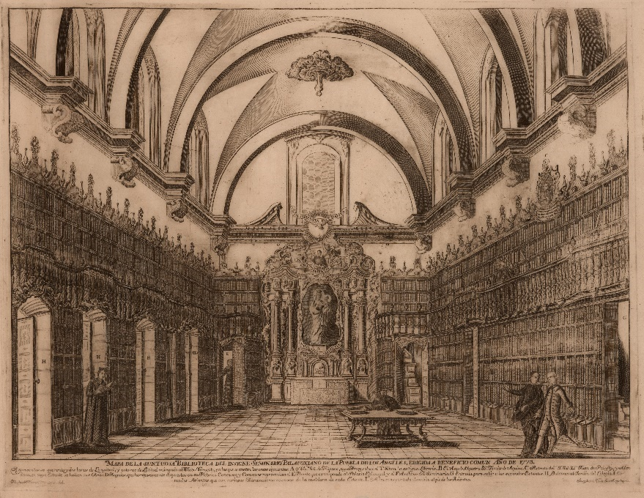
Fig 1. The Architecture Plan & Elevation of Bibliothèque nationale de France
Source: https://www.suzanneborderies.com/bibliothque-nationale-de-france-study
Fig 2. Spaces Analytical Floor Plan for the middle part of the Bibliothèque nationale de France Source: https://www.suzanneborderies.com/bibliothque-nationale-de-france-study
National Libraries
National libraries can be found in most of the countries, they are responsible for publishing and maintaining the national bibliography, collect and preserve the national literature.
Most national libraries have the right to receive one free copy of each book and periodical printed in the country. Certain other libraries throughout the world share this privilege.
The National Library of France is based on a rectangular area of around 16,000 square meters, the typology concept of the library is constructed on a grid system. The main axis starts from the entrance and lobby till the reading room through the book storage.
The grid system also influences the ceiling which has 9 big stone domes and positioned to have joints between each other, the cupolas are supported by iron arches that are in turn mounted on 16 slim cast iron columns that reach down to the floor.
These cupolas were designed to penetrate the natural daylight to the reading hall to illuminate the whole area by the reflective materials in the walls and floors making the entire area lightened during the day. [2]
Typological Types of Libraries
Library activities throughout the world are so much different in from country to country, but the most general factor of their activities is that, they follow a pattern which has evolved over the years.
There is a categorization for the libraries according to their activities and roles as the following:

Public Libraries
Public Libraries has also a big social role for offering special facilities which may be provided for the old, the blind, the hearing-impaired, and others, and in many cases library services are organized for local schools, hospitals, and jails.
In the 19th century, that a library’s provision was a legitimate charge on public funds. It required legislation to enable local authorities to devote funds to this cause.
Public libraries provide well-stocked reference libraries based on the systems
of branch libraries. Branch Libraries are also supplemented by traveling libraries, to serve outlying districts.
The Palafox Library of 1646 is a 140 ft long is the first and oldest public library in the Americans.
The classical altarpiece style has made the identity of the library as seen from the statues, cornices around the ceiling’ windows.
The domed ceiling design with glass windows was intended to lighten the space with light, bookcases are designed to be made of cedar wood. [3]

Fig 3. Puebla, Mexico: Palafox Library. Illustration of 1773 by Miguel Jerónimo Zendejas
Source: https://en.wikipedia.org/wiki/Biblioteca_Palafoxiana

School Libraries
Where public libraries and schools are provided by the same education authority, the public library service may include a school department, which takes care of all routine procedures. In most countries, schools and public libraries cooperate closely.
School libraries have been the scene of significant research and experiment with many different media, so much so that some school libraries have become resource centers. Teachers accustomed to using visual aids, often indeed to making their own, have come to expect the library to provide such materials as collections of photographs, slides, films and filmstrips, videotapes, and artifacts for work in subjects such as history and mathematics. [1]

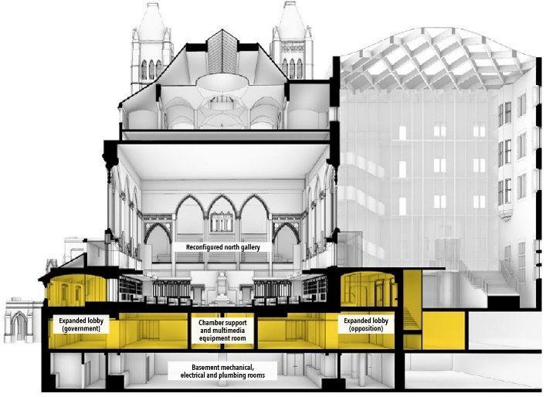
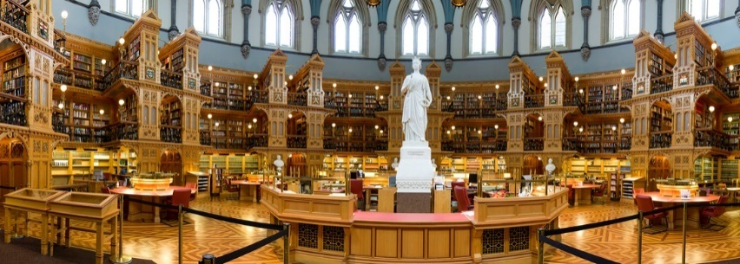
Special Libraries
Fig 5. The Library of Parliament in Ontario, Canada built in the Gothic revival architectural style.
Source: https://www.tpsgc-pwgsc.gc.ca/citeparlementaire-parliamentaryprecinct/decouvrez-discover/bibliotheque-library-eng.html

Fig 4. The Library of Parliament in Ontario, Canada. Cross-Section Source: https://www.tpsgc-pwgsc.gc.ca/citeparlementaire-parliamentaryprecinct/rehabilitation/edificeducentre-centreblock/elements-eng.html
The national, university, and public libraries are parts of general libraries which more or less gives a potential for public to access them. They also take part in the special libraries too, which are built around a special subject of interest. Beyond this network are a large number of libraries established by special groups of users to meet their own needs.
Special libraries are frequently attached to other official institutions such as government departments, hospitals, museums etc. They are also planned on strictly practical lines, with activities and collections carefully controlled in size and scope, even though these libraries may be and in fact often are large and wide-ranging in their activities; they cooperate widely with other libraries. [2]

The Library of Parliament has unique massive flying buttresses, ornamental ironwork and handcrafted detail, and the abundant natural light around the whole space. That named the library’s architecture design by
“An Architectural Marvel”
Inside, the Library's white pine paneling contains carvings of thousands of flowers, masks and mythical beasts. Its galleries display the coats of arms of Canada and the 7 provinces existing in 1876. In the center of the room stands a white marble statue of a young Queen Victoria, sculpted by Marshall Wood in 1871. [4]

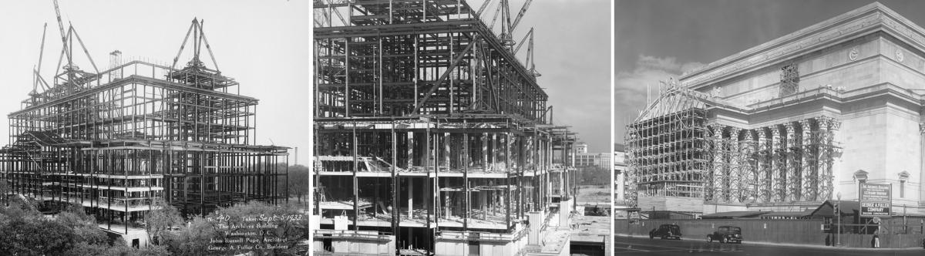
Archives
Until the mid-15th century, the use of the printing press, such records were not distinguished from library materials and were preserved in the same places as other manuscripts.
The importance now accorded to public records has been recognized as one outcome of the French Revolution, when for the first time an independent national system of archive administration was set up, for whose preservation and maintenance the state was responsible and to which there was public access.
Among the best known, are the Archives Nationals in France, the U.S. National Archives, and the National Archives (formerly the Public Record Office) in the United Kingdom. [1]

Fig 6. The National Archives History Office preserves and promotes the history of the National Archives.
Source: https://www.archives.gov/about/history
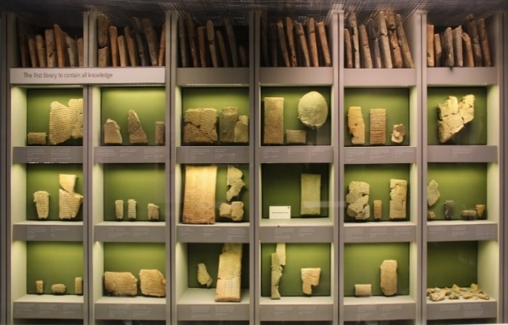
Private Libraries
These libraries are owned by private individuals, and vary in their range of interest according to their owners.
Mesopotamia was home to a great number of private libraries, many with extensive collections of over 400 tablets. The nucleus of these private libraries were primarily texts which had been transcribed by the proprietors themselves from the time they acquired their education in the art of the scribe. As insignificant as these libraries may seem, they established the basis for the Library of Ashurbanipal collection.
In the modern ages, collectors of private libraries have sometimes benefited posterity by leaving their collections to public institutions or founding a library. The tradition has long been established in Europe, where many important libraries have been built up around the nucleus of a private collection. [1]

Fig 7. Library of Ashurbanipal Mesopotamia 1500-539 BC Gallery, British Museum, London, England, UK
Source: https://en.wikipedia.org/wiki/Library_of_Ashurbanipal#/media/File:Library_of_Ashurbanipal.jpg

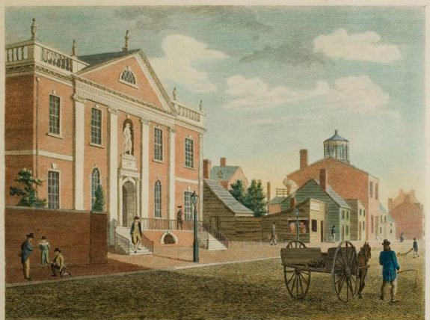

Subscription libraries

Part public, part private, that is financed by private funds either from membership fees or donations, these libraries enjoyed much popularity from the late 17th to the 19th century. Many of them were set up by associations of scholarly professional groups for the benefit of academies, colleges, and institutions, but their membership was also open to the general public.
Some of them are still in existence, perhaps the most famous are the Library Company of Philadelphia, founded by Benjamin Franklin in 1731, the Boston Athenaeum, founded in 1807; and the London Library, opened largely at the request of Thomas Carlyle in 1844
During the 19th century, the great size of many subscription libraries enabled them to wield much influence over publishers and authors. Nevertheless, these libraries were for the most part unable to survive, and the service they gave is now largely provided by the free public libraries. [2]

Fig 9. The Library Company of Philadelphia, founded by Benjamin Franklin in 1731.

Source: https://philadelphiaencyclopedia.org/archive/library-company-of-philadelphia/

Historical Typological & Development, Principles and Characteristics of Libraries in History

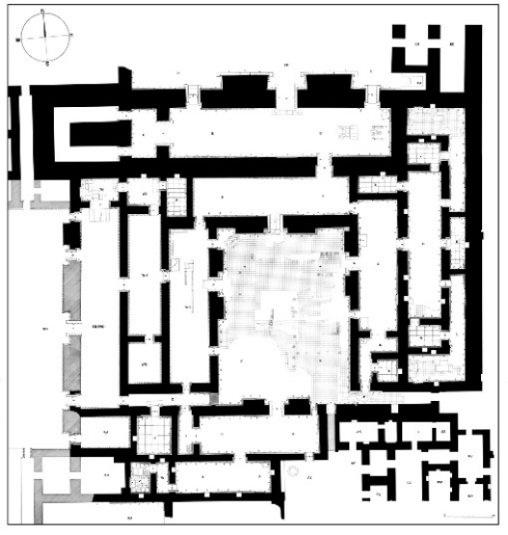
The Libraries in Antiquity
Eastern Libraries
Libraries consisted of writings that used leather scrolls, wooden writing boards covered in wax, papyrus, and clay tablets.
Later, other media kept the written records and texts using several tablets, sometimes as many as 100. Languages used included cuneiform, Akkadian, Sumerian, Hurrian, and Greek. [5]
The cultures of the Near East had three types of libraries, a diversification which was seen later in many states elsewhere. These were the library within Royal palaces, at Temple sites, and in Private homes. The most common were the Temples’.

The Assyrian palace library at the capital Nineveh, often called the Library of Ashurbanipal for Sennacherib, the King of Assyria (r. 668-627 BCE). This library was largely composed of texts in cuneiform and covered just about everything the kings could get their hands on from hymns to myths.
Scholars estimate that just the tablet section consisted of 30,000 clay tablets, and those that were part of Ashurbanipal's private collection are especially finely written and sealed. [6]
The typology of the palace is said to follow the same type of the Assyrian palace’s architecture characteristics from wall Depictions & Figure to the Plaster materials and dominant buildings.

Libraries were the identity of large cities in the ancient civilizations, the architecture of the libraries witnessed the development of architecture of different styles and art. There were famous libraries of this kind such as libraries in Alexandria, Athens, Constantinople, Ephesus, and Nineveh. These libraries were the vault for the secrets of these civilizations until today.
Libraries in ancient eras were not always designed for the public; unlike the Roman period, which had genuinely public libraries which were open for the public to come and read as they wished.
Many libraries in the Near East and Egypt were attached to sacred temple sites or were part of an administrative or royal archive, while in the Greek and Roman worlds these types continued but private collections became much more common too.
Ancient texts were typically kept in many forms such as scrolls made of papyrus, leather, or inscribed on wax or clay tablets. [1]

Papyrus scrolls were typically long, as 6-8 m (20-26 ft.) And, sometimes both sides were used to write on, typically in columns and with a wide margin left blank for later notes. [1]

Fig 11. Illustration of Ancient Assyrian Palace.

Source: https://digitalcollections.nypl.org/items/510d47dc-4722-a3d9-e040-e00a18064a99

Fig 10. The Plan of Assyrian Palace.

Source: Paley & Sobolewski [1987] plan 2e00a18064a99

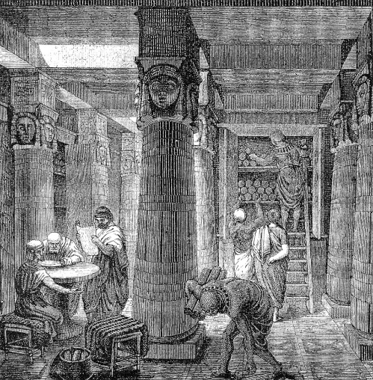
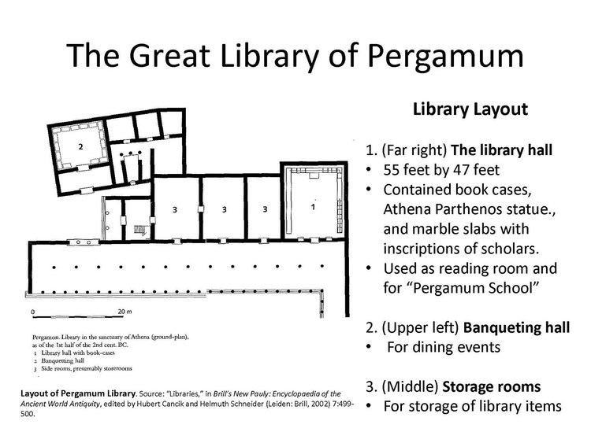
Fig. 14 Illustration for The Royal Library of Alexandria, 3rd century BC, Alexandria, Egypt
Source: https://en.wikipedia.org/wiki/Library_of_Alexandria#/media/File:Ancientlibraryalex.jpg
The library’s identity reflects the ancient Egypt’s architecture such as the stone walls, geometric ceilings and flooring.
Columns are positioned in a regular symmetrical grid with depictions and sculptures are curved in the stone columns.

Ancient Egypt Libraries
Ancient Egypt had many different types of libraries, which could be pure archives or as they named them 'house of books', 'house of writings', and 'house of the divine words'.
In the Near East, Egyptian libraries were frequently part of temple sites or royal palaces.
The Alexandria Great Library was the landmark of the world history libraries at this time which was founded by “Ptolemy II Philadelphus (r. 285-246 BCE)”.
Alexandria library was A combination of a royal and public library, it was one of the earliest to permit someone not actually charged with looking after the library to enter and study therein the 500,000-700,000 scrolls.
The library was divided into sections for a better organization of the vast contents. [1]

Fig. 12 Isometric Illustration for the Library of Pergamum
Source: https://holylandphotos.wordpress.com/2017/06/12/pergamum-turkey-library/
Fig. 13 Plan of the Library of Pergamum
Source: https://alchetron.com/Library-of-Pergamum#library-of-pergamum-32c0f7aa-c1aa-4f36-8c28-23811edd84f-resize-750.jpeg
The Greek Libraries

Pergamum
Most of the large Greek temples used to had their own libraries as well as having their archives in some temples. The first important institutional libraries in Athens began during the 4th century BC their texts were written on perishable materials such as papyrus and parchment.
In Minor Asia, a library that was similar to the one in Alexandria was set up at Pergamum during the reigns of Attalus I Soter (d. 197 BC) and Eumenes II (d. 160/159 BC). [1]
The Pergamum Library was constructed in the 3rd century BC, it had 4 rooms, 3 of them were dedicated to the library alone and the last was used as a meeting space.
Ceiling had grids of profiled and dug squared along the whole ceiling area. The columns also were the identity for the building, Infront of every room there were 2 standing columns
The middle open court was the divider between the north & south and access to the theater space.

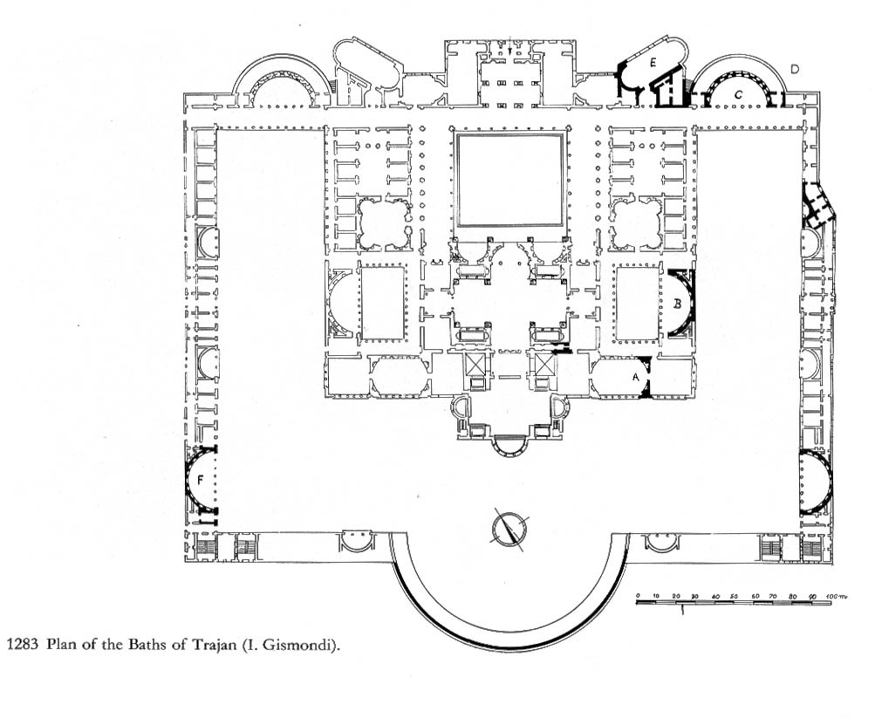
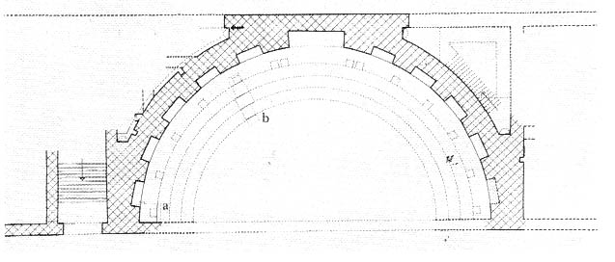
Figure. 15 Bath of Trajan plan
Source: https://people.duke.edu/~wj25/uc_web_site/libraries/bath%20libraries/photo%20album/pages/trajan%20plans.htm
Figure. 16 The library’s plan of Trajan’s Path
Source: https://people.duke.edu/~wj25/uc_web_site/libraries/bath%20libraries/photo%20album/pages/trajan%20library%20plan%20W.htm
Roman Libraries
Roman libraries were attached to temples, palaces, and state archives, and, as in Greece, the gymnasium-library combination, now called the palestra. The interior of Roman libraries was tended to be divided into two areas: one for Latin and another for Greek works.
The Romans spread the idea of public libraries across their empire with famous ones being established at Ephesos (, completed in 117 CE) and Athens (the Library of Hadrian, completed c. 134 CE). Other famous libraries of the 2nd century CE included those at Rhodes, Kos, and Taormina (Tauromenium). [1]

The identity of Roman’s Architecture is obvious in the Trajan’s Bath through the half rounded geometric form of buildings which have more than one floor. Also, the columns which are still existed in the façade of the library’s remains.
The stairs are important feature in the Roman buildings, the middle court which was the place for important events is linked with stairs which can also lead to the interior of the library in some parts of the bath.

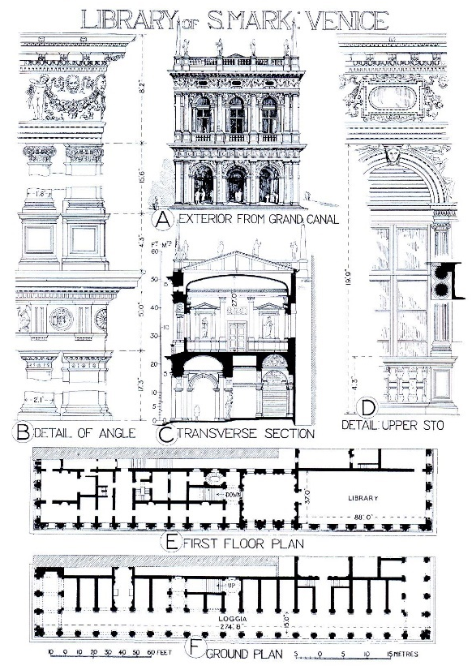
Byzantine Libraries was influenced by the Christian Religion
That was reflected in the Façade where they added religious iconic figures and statues on the exterior façade of the building.
The Cross shape also could be clear on the façade in Windows, Columns or Sculptures.
The interior of the library proves the interest of using Mosaic in walls or ceiling in Byzantine Architecture, the depictions and paintings also were important parts of the Byzantine architecture identity.

Byzantine Libraries
The Byzantine Empire had an imperial library and a patriarchal one for much of its history and boasted one of the great libraries at Constantinople with its 120,000 scrolls (it burnt down c. 475 CE).
Byzantine monasteries weren’t for public but on the other hand they became the great preservers of ancient texts in their libraries, as libraries begad to have less role. [1]

Fig. 17 Floor plans and Elevations of St Marks Library, Venice, Italy
Source: https://commons.wikimedia.org/wiki/File:Library_of_St_Marks_740.jpg
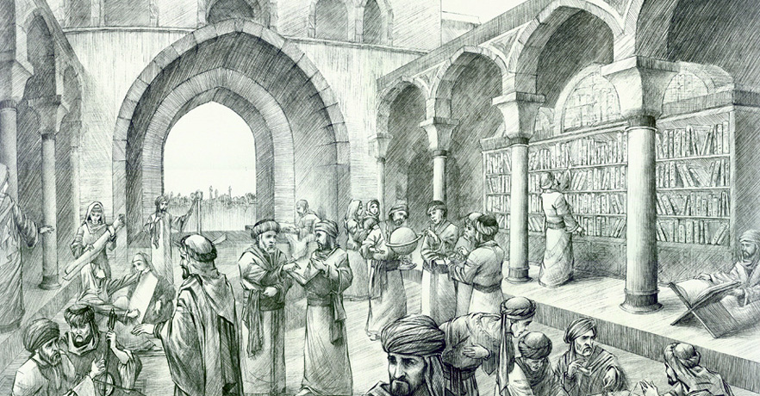
Fig 18. Illustration for the Library of the Islamic House of Wisdom
Source: https://www.islamicity.org/60008/baghdad-the-house-of-wisdom-bayt-al-hikmah/

The Islamic Libraries
The establishment of libraries of sacred texts, was especially in mosques such as al-Aqsa in Jerusalem (c. 634) and the Great Mosque (Umayyad Mosque) of Damascus (c. 721). By that time the Umayyad collection included hundreds of works on astrology, alchemy, medicine, and military science.
Other libraries of the Islamic world were also founded in Baghdad, Cairo, Alexandria, and also Spain, where there was an elaborate system of public libraries centered on Córdoba, Toledo, and Granada.
The House of Wisdom also known as the Grand Library of Baghdad, refers to either a major Abbasid public academy and intellectual center in Baghdad or to a large private library belonging to the Abbasid Caliphs during the Islamic Golden Age.
The House of Wisdom and its contents were destroyed in the Siege of Baghdad in 1258. [1]

The architecture of the House of Wisdom’s library identifies the typical Islamic elements, such as arches on walls and windows, also arches between the columns.
The library which also has some arches, clearly lays behind tall arches and columns.
There was a big space in the middle of the library for scholars to discuss.

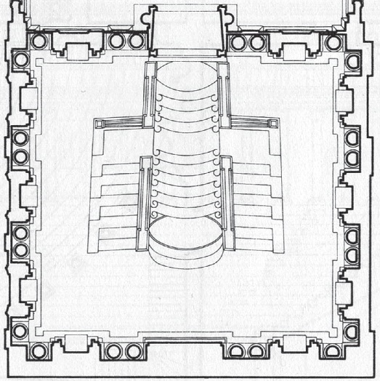
Libraries of Europe in the Medieval & the Renaissance (5th to 15th Century)
As religion became a lot more significant in the Middle Ages. In 380 AD eventually, Christianity became the official religion of Rome. The Christian views continued to spread across Europe. By the 8-10th century the majority of the leaders in Europe had Christian views. This obviously had a big impact on the library structure and the theme of the books too. [7]
The Laurentian library of Michelangelo strongly reflects the Renaissance architecture. Symmetry is achieved as seen in the Elevation and Plan.
Niches are around the library’ windows from outside and inside as well.
Proportion occurred through using tall and shorter niches in all windows.

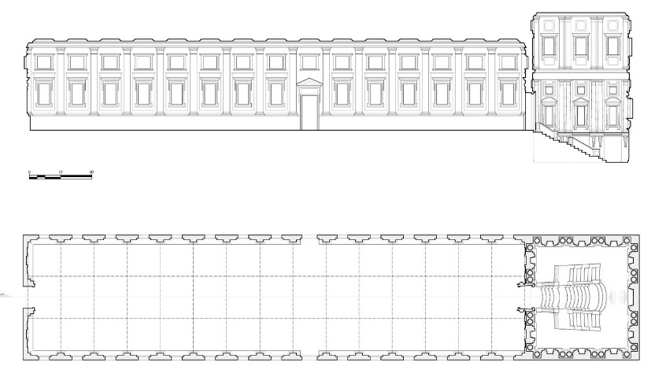

Fig 20. The Laurentian Library Staircase
Source: https://www.chrisbaileyarchitecture.com/laurentian-library
Fig 19. The Laurentian Library Plan and Elevation of Michelangelo
Source: https://www.chrisbaileyarchitecture.com/laurentian-library
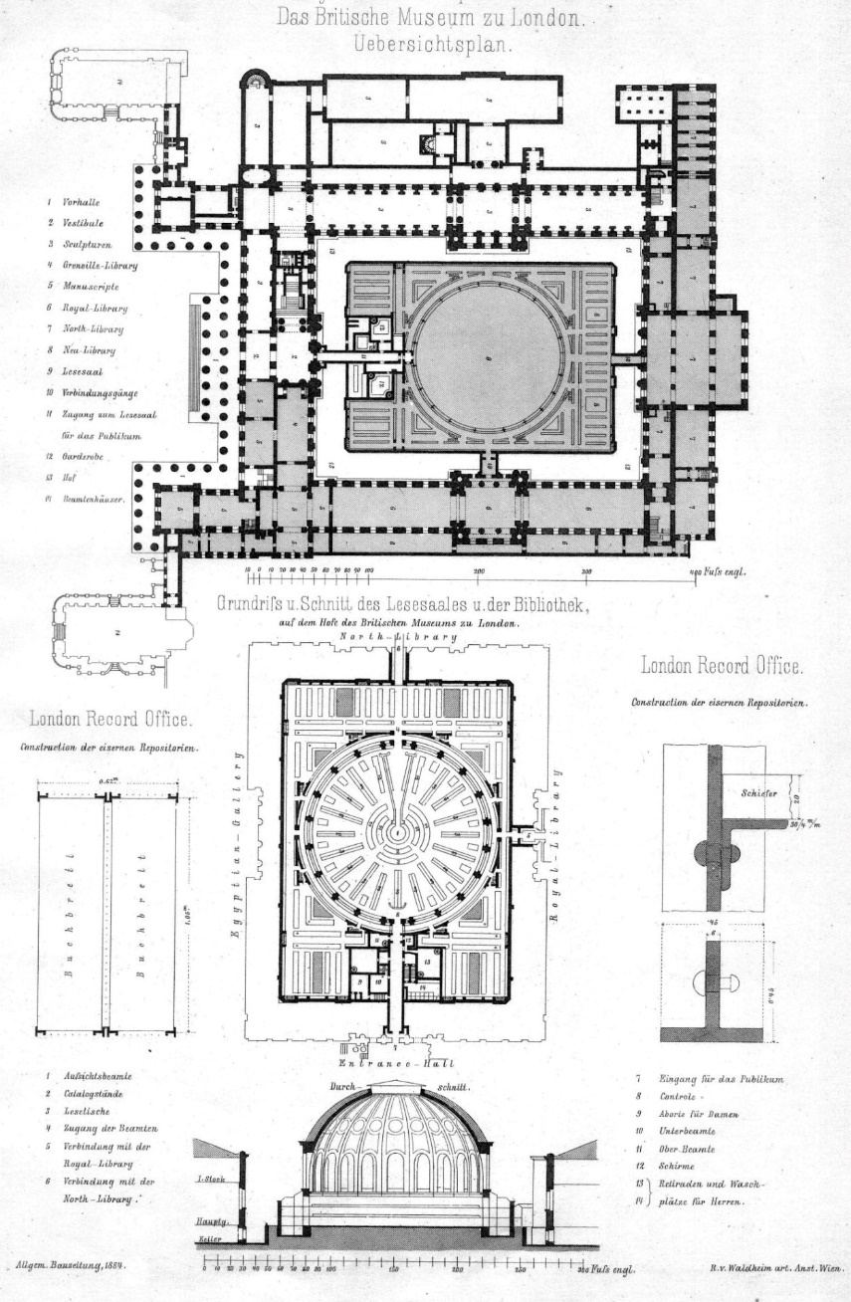
Europe Libraries in the Modern Ages
(Enlightenment and Romanticism 17th – 19th Century)

The Enlightenment itself was an intellectual and philosophical movement spreading rapidly throughout the western world, it did also
bring new concepts and ideas, emphasizing liberty, individualism, and progress.
These circumstances helped to the development of libraries. [7]

Besides the rapid growth of the (partially) public libraries, the openings of new university and private subscription libraries also helped the development of libraries role.
These organizations also allowed individuals outside of the institution to enter.
The 18th century was also the age of great national libraries. The first truly national library was founded in 1753 as part of the British Museum, and many followed later in the 1700s and 1800s.

Different library types were founded to store the relevant resources and. Besides the national libraries, school libraries were reinvented, and specialized libraries appeared in this period. [7]

The King’s library of 1823, nowadays is the first wind of the British Museum Building.

The room was on a grand scale at that time, based on 91m (300ft) long, 12m (41ft) high and 9m (30ft) wide and its large dimensions required special approach for its construction, with the use of cast irons beams to support the ornate ceiling. [8]

The Architecture of the reading room in the new building of the British Museum of 1852, is designed with the Greek style and also inspired by the Roman’s Pantheon, the bookcases are built to surround the room are 3 miles in length, and were made of iron to hold the books’ weight and resist the fire.
The entrance of the building has 44 Greek Ionic ordered columns of 14m high.
The dominant dome also featuring the reading hall with its surrounding cornices and frames.

Fig 21. Plans and Section of the British Museum & Library
Source: https://archimaps.tumblr.com/post/72138770901/plans-and-elevation-of-the-british-museum-and
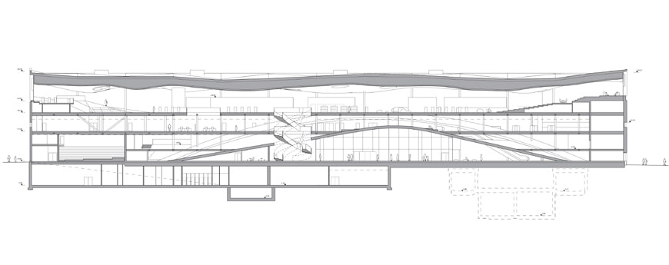
The design typology for the library on the last floor is to make it accessed with Natural-Light from all directions even from the top through the Sky-Light openings in the ceiling.
The interior shape of the top floor is symmetrically centered around the ceiling, featuring the shades of the top floor throughout the incoming lights.

Central Library Oodi in Helsinki, Finland
Opened on December 5, 2018, the Helsinki Central Library, also known as Oodi (meaning ode in Finnish), is widely regarded as one of the most exciting new public venues built in Finland in the last years.
Designed by Helsinki-based ALA Architects. Oodi is a typical example of a new generation of public buildings that combine a “traditional” library and a community center into an information access facility,
to create a multipurpose building open to all, “a place of freedom and equity for the users”.
The 17,250-square-meter building consists of three levels (a fourth, underground level contains technical facilities), each accommodating a different set of functions. Together with a large public lobby, the ground floor contains several spaces for “fast-paced, ever-changing” activities, including special event facilities, a multi-purpose hall, a movie theater and a cafe-restaurant.
The second floor is dedicated to creative and social activities for individuals, groups, and families and accommodates meeting spaces.
The third floor has the library facility, designed as a large and open space to maximize and penetrate the space with daylight.
For further reinforce the concept of a library open to the city, the architects shaped the main facade of the building as a long Finnish spruce-clad twisted surface
The glazed volume of the reading room tops the wooden facade like ice crust on driftwood. [9]

Current Libraries Typological Situation & Designs in Europe and Czech Republic

Europe is very rich with libraries of the different styles, from the old ones which remained through the different consecutive civilizations and era’s that reflect the typology of the library’s architecture at these times, to the newly built libraries, which are also iconic and not less in beauty than the ancients.
New libraries have the advantage of fulfilling the public needs with the new modern requirements, as well as being impressive to attract people’s interest.
They are no longer just a place for only education but also a destination for people and tourists to see the beauty of the architecture and design.

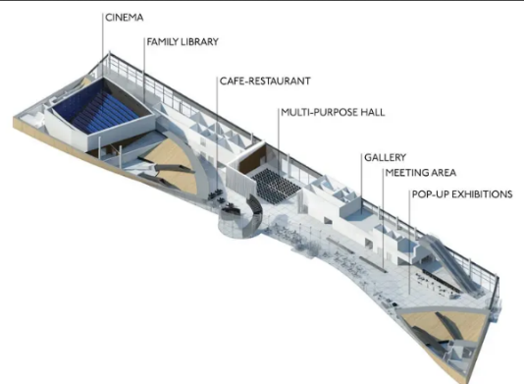
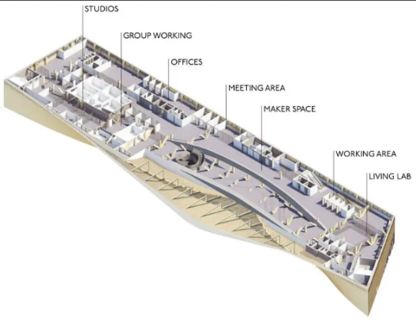
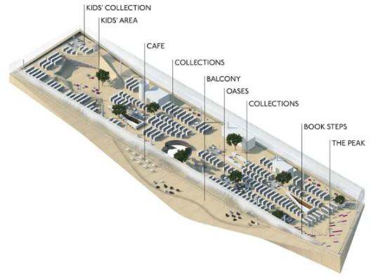
Figure 22. Cross-Section of the Oodi Library Building
Source: https://www.inexhibit.com/case-studies/oodi-helsinki-central-library-ala-architects/

Figure 23. Schematic drawings of the ground, second and third floors. Images courtesy of ALA Architects
Source: https://www.inexhibit.com/case-studies/oodi-helsinki-central-library-ala-architects/
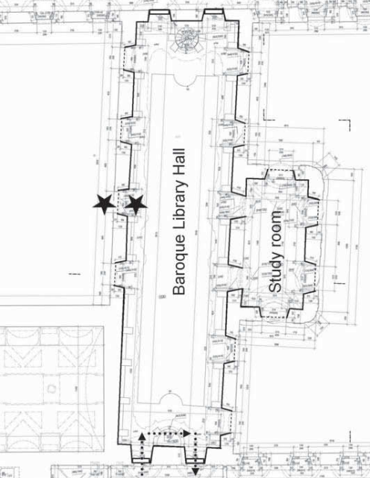
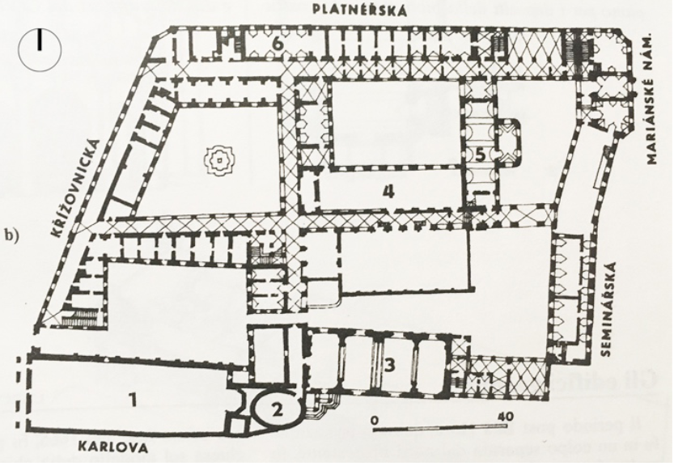
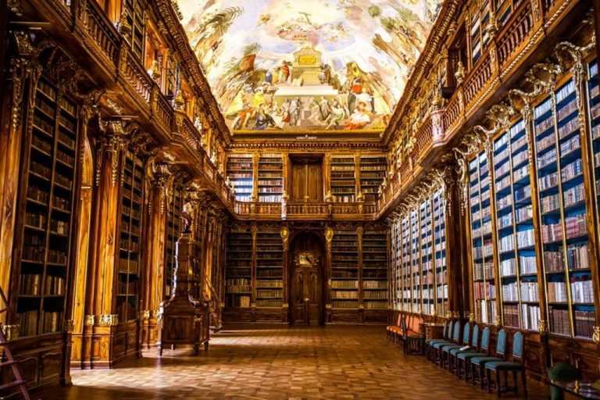
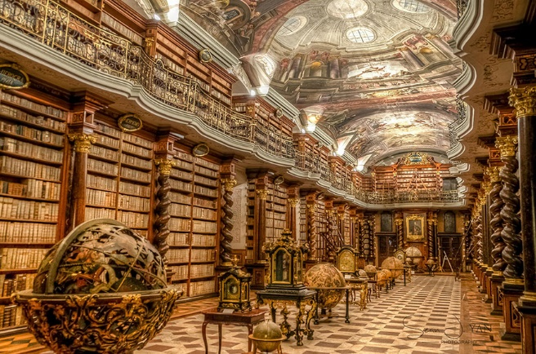
Realization Examples of Libraries in Czech Republic

The National Library of Czech Republic, Prague
(The Baroque Library Hall, Klementinum - 1722)
The baroque library was first opened in 1722 as a part of the Jesuit university based in Klementinum. It houses over 20,000 volumes of mostly foreign theological literature.
The interior of the baroque library has remained intact since the 18th century. The hall is decorated with ceiling frescoes by Jan Hiebl depicting allegorical motifs of education, and portraits of Jesuit saints, patrons of the university and prominent representatives of this order.
The top of the hall is a portrait of Emperor Joseph II., who arranged for the books from abolished monastic libraries to be sent to Klementinum. Also remarkable is the collection of geographical and astronomical globes in the center of the library. These are mainly works of the Jesuits. Among the globes are also astronomical clocks, constructed mainly by Jan Klein. [10]
The bright painted ceiling is reflecting the outstanding Baroque paintings and colors.
The symmetry can be seen along the entrance axis on both sides.
The Cornices are going around the middle ceiling continuously to the top ceiling edges.

Figure 24. The floor plan of Prague’s Klementinum Library.
Source: Jiří Smolík Characterization of airborne particles in the Baroque Hall of the National Library in Prague. Page 4.
Figure 26. The interior of the Klementinum Baroque Library Hall
Source: https://theculturetrip.com/europe/czech-republic/articles/5-photos-that-prove-prague-has-the-worlds-most-beautiful-library/
Figure 25. The whole floor plan of Prague’s Klementinum. The library is referred with 4.
Source: C. Stanga 2, H. Hasníková 3, R. Brumana 1, A. Grimoldi 2, F. Banfi 1GEOMETRIC PRIMITIVES ASSESSING ITALIAN-CZECH VAULT CONSTRUCTION TECHNIQUES IN BAROQUE PERIOD. Page 4.
Figure 27. The interior of the Klementinum Baroque Library Hall
Source: https://theculturetrip.com/europe/czech-republic/articles/5-photos-that-prove-prague-has-the-worlds-most-beautiful-library/
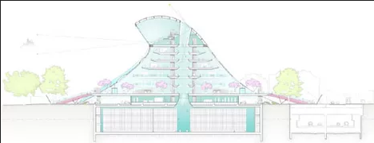
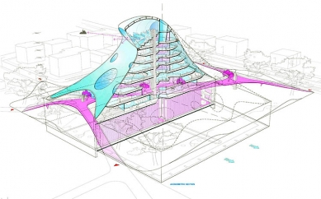
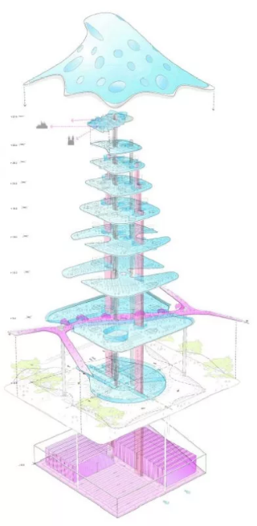
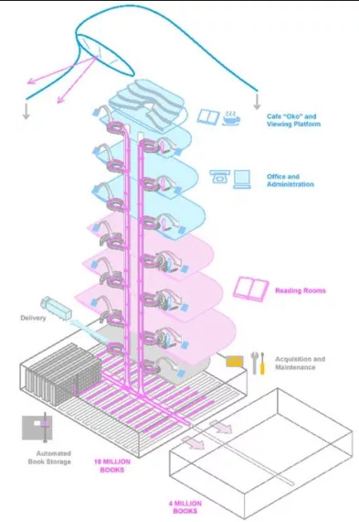
Fig 30. 2D Section of the Library
Source: https://en.wikiarquitectura.com/building/national-library-of-the-czech-republic/

Fig 28. Structural Layers of the Library
Source: https://en.wikiarquitectura.com/building/national-library-of-the-czech-republic/

Fig 29. Isometric Cross-Section of the Blob Structure
Source: https://en.wikiarquitectura.com/building/national-library-of-the-czech-republic/

The Futuristic Blob National Library of Czech Republic
(By, Jan Kaplicky, Amanda Levete)

The futuristic systematic library by Jan Kaplicky and English architect Amanda Levet is based on a concept of having a high visual impact, the architectural landmark of which the plasticity and color are prevailed.
The three-dimensional object minimizes the volume used. The building 9 floors and reaches 50 meters in height. It’s positioned on a platform, with sectors of the perimeter on raised edges to reflect the building from different angles. It’s also covered by a pyramidal skin envelope of undulating and morbid forms, with a widened base and rounded edges giving impressions of octopus, mushrooms or jellyfish.

The Typology of building is unusual related to the identity of the City of Prague. The facade has a gradual greenish color tint to the yellow at the base, up to an almost white tone at the top. The windows are violet tones.
The design allows Natural Light to fill the reading rooms which are located on a street entrance prepared as public space.
The walkway which is a great feature runs on the first level and is meant as a direct connection to the park. Also, to link between the indoor and outdoor spaces.
The skin envelope with circular openings provides natural light during more than 70% of the operating hours of the library. However, the amount of glass openings is just 15% of the area of the skin.

The structure is designed as a skeleton of steel columns with an internal grid of 12 by 9 meters which supports forged steel beams and slabs of concrete.
The skin envelope is hung, supported by a ring-shaped beam located at Level 7. [13]

Sources
- Britannica (July 20 1998), "Library". Encyclopedia Britannica, https://www.britannica.com. Retrieved from https://www.britannica.com/topic/library.

- Chabelie Rodriguez, “, Bibliothèque nationale de France - Henri Labrouste, https://www.suzanneborderies.com. Retrieved from https://www.suzanneborderies.com/bibliothque-nationale-de-france-study

- “Biblioteca Palafoxiana.”. Wikipedia, The Free Encyclopedia, https://en.wikipedia.org/wiki/Main_Page,
12. April. 2012. Retrieved from https://en.wikipedia.org/wiki/Biblioteca_Palafoxiana

- “Explore the Library of Parliament”. 6. April. 2021, Retrieved from https://www.tpsgc-pwgsc.gc.ca/citeparlementaire-parliamentaryprecinct/decouvrez-discover/bibliotheque-library-eng.html

- Cartwright, M (2019), WorldHistory, " Libraries in the Ancient World". World History Encyclopedia, https://www.worldhistory.org, 23 July 2019, Retrieved from https://www.worldhistory.org/article/1428/libraries-in-the-ancient-world/.

- “Library of Ashurbanipal”. Wikipedia, The Free Encyclopedia, https://en.wikipedia.org/wiki/Main_Page.
Retrieved from, https://en.wikipedia.org/wiki/Library_of_Ashurbanipal

- Robert. K (2021), “The History of Libraries III. – Enlightenment And Romanticism.”. Princh,
https://princh.com/, March 25th. 2021, Retrieved from https://princh.com/blog-the-history-of-libraries-enlightenment-and-romanticism/#.YdzEFVnRaUk

- “The British Museum Story”. https://www.britishmuseum.org
Retrieved from https://www.britishmuseum.org/about-us/british-museum-story/architecture

- “Oodi Helsinki Central Library, ALA Architects”. 23th November. 2019, https://www.inexhibit.com/
Retrieved from https://www.inexhibit.com/case-studies/oodi-helsinki-central-library-ala-architects/

- Bocco D (26 July 2018). Is This the Most Beautiful Library in Europe? https://theculturetrip.com/ Retrieved from https://theculturetrip.com/europe/czech-republic/articles/5-photos-that-prove-prague-has-the-worlds-most-beautiful-library/

- C. Stanga 2, H. Hasníková 3, R. Brumana 1, A. Grimoldi 2, F. Banfi 1 (May 2019) GEOMETRIC PRIMITIVES ASSESSING ITALIAN-CZECH VAULT CONSTRUCTION TECHNIQUES IN BAROQUE PERIOD

- Jiří Smolík (January 2010). Characterization of airborne particles in the Baroque Hall of the National Library in Prague

- National Library of the Czech Republic. Retrieved from https://en.wikiarquitectura.com/building/national-library-of-the-czech-republic/

