Churches
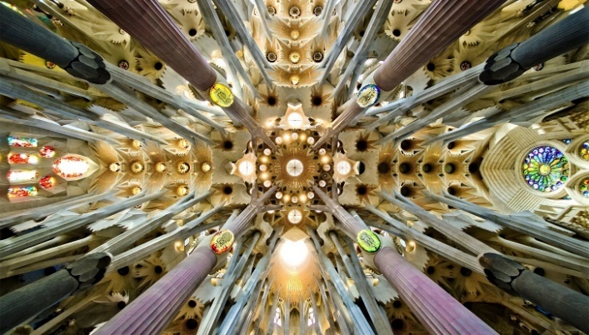
History, Typology & Practical Application

Weldesamuel, Muse Tadiose | VSB-OSTRAVA, Building typology, practical theory

Contents

Table of Figure 2
Introduction 3
1. Basic concepts 3
2. Historical development 4
House Church 4
The Hall Church 4
The Basilica Church 5
Eastern Orthodox Church 6
6
Romanesque 6
Gothic 7
Renaissance 7
Baroque 8
8
Eclecticism 8
Modern 9
Post-Modern 9
3. Basic typological principles, typological characterization 10
The Western Roman Catholic Church Type 10
The Eastern Orthodox church type 12
4. The current situation in the Czech Republic and Europe 14
5. Realization examples in the Czech Republic 14
St. Barbora, Kutná Hora, Czech Republic 14
St. Nicholas Church, Mala Strana, Prague 14
Reference 16
Index 18

Table of Figure

Fig 1 Dura-Europos house church,3rd BC. A) pre & post alteration, after Kraeling 1967 plans IV & V b) Hypothetical reconstruction by Wladek Prosol 4
Fig 2 S. Julianus, Umm al Jamal 345, after Butler, 1969: 18, ill. 11 4
Fig 3 Old St Peter's Basilica. A) Plan b)3d cross section 5
Fig 4 Plan of Campanopetra Basilica, Salamis 5th-6th C, 1980 5
Fig 5: Hagia Sophia (Aya Sophia) in Constantinople (Istanbul, Turkey). 537 AD a) Plan b) cross-section 6
Fig 6 Plan of Saint-Étienne, France, 12th c 6
Fig 7 Cathedral of Notre-Dame in Paris,1163 – 1345 a) plan b) Cross-section 7
Fig 8 Peter's church, Rome. the forum was built in the later stage of the renaissance (Baroque) a) Plan b) Cross-section 7
Fig 9 San Carlo alle Quattro Fontane, Rome a) Plan b) Cross-section 8
Fig 10 Basilica of St. Peter and St. Paul, Prague a) Picture from the side b) Picture from the front side 8
Fig 11 Neuterd de Roschamp church, Le Corbusier, france,1954 a) Plan b) Sectional 3D 9
Fig 12 3D visualization of Hallgrimskirkja church, Reykjavik, Iceland,1937-1986 9
Fig 13 Basic layout & terminology of Basilica church floor plan 10
Fig 15 Inside Roman Catholic Church 3d illustration 11
Fig 14 Sectional 3D representation of Roman Catholic Church layout & Terminologies 11
Fig 16 Variation of the Basilica Church layout b-Nave church, a-Old Basilica, c, Pre Romanesque, d-Romanesque, e-Gothic cathedral 12
Fig 17 Planar illustration of Orthodox Church type 12
Fig 18 Eastern Orthodox church layout a) Plan b) Cross-section 12
Fig 19 Sectional 3D representation of Orthodox Church layout & Terminologies 13
Fig 20 Variation of Orthodox centralized churches a) Cross in square b) Cruciform c) Composite 13
Fig 21 St. Barbora church, Kutná Hora 14
Fig 22 St. Nicholas Church,Prague 14
Fig 23 Church of Beatified Restituta a) Plan b) Cross-section 15
Fig 24 Church of Beatified Restituta a) Illustration of the concept b) Interior view 15

Introduction

The word Church comes from the Greek word ‘Ekklesia’. ‘Ek’ Meaning ‘Out of’ and ‘Klesia’ meaning ‘to call’. The called-out ones as its true definition, Church is a metaphor of heaven to summon humans out of the world.[1] Churches are a building for worship. According to Merriam- Webster the word church means a building that is used for Christian religious services. “The Christian religious community as a whole” as the Christian doctrine describes it, although in the past some other religions used it for devotions of other gods.
Day of Pentecost, the prayer by apostilles with St. Mary, nine (9) days after the ascension of Jesus Christ in 33 AD is said to be the origin of the church. The apostilles become the leaders of the church and spread Christianity from Rome to all over the world teaching in public arenas, Houses, and eventually in well-organized property-Churches.[1]
The essay focuses on the history of churches architecture, how the architectural style changed through time concerning the believers, and the current design trend. It also mentions some realized projects around the world.

Basic concepts

The history of churches defines the history of Architecture in general. Thus, to identify the typologies of the church we must closely examine their chronological order. [2]The purpose of churches though never changes, they serve as a religious institute where the words of the Messiah, Jesus Christ's word are taught. The space organization is mainly based on the scenario of the ritual activity where the “Last super” of Christ took place. Church layouts tend to have a focal point where the worshipers tend to focus on praying and fellowship like the apostles gather around Jesus Christ in his time of perching.
The teaching is accompanied by the Eucharist, where Jesus represents his body and the covenant of his blood by bread and a drink respectively. Telling the apostilles the only way to heaven is if a believer takes this sacramental representation of Jesus's body and blood on the top of his good deed. The focal point embodies this secrete and is implemented alongside the place where religious teaching takes place. The layout of a Church is dictated by this phenomenon. [3]
Churches are the gateway to heaven according to Christians. They speak for the heavenly peace, consistency, focus, Oneness, equality, happiness, the Messiah brings to the earth, in terms of Architectural terms like Proportion, rhythm, emphasis, unity balance, and harmony. They also oriented toward the east to represent the resurrection of Christ. Even if the type of churches varied because of the divergence of Christianity through time, the basic Architectural terms and layout listed above were and still are the major concept of churches.

Historical development

House Church

From 1st-3rd AD Christians adapted their houses for a synagogue to spread Christianity. The wealthiest member residence was chosen for prayer and gathering. Because of the continuous pressure of the Roman empire, places which have an inward layout with a courtyard were selected for secrecy. The linear arrangement, Dias in the east end of the room was a typical layout for the space of prayer.[4]
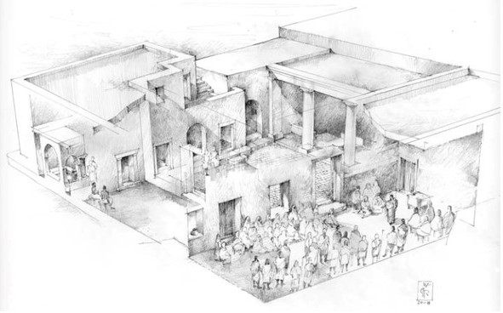
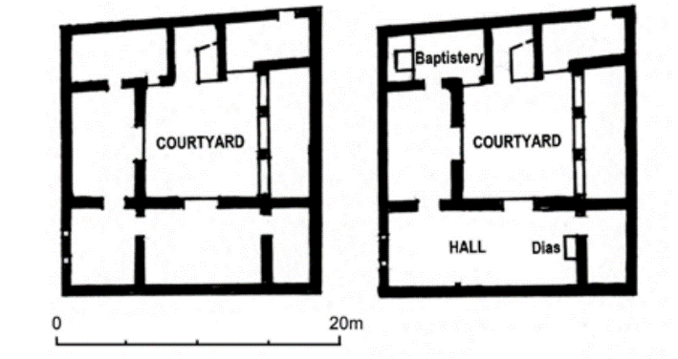
Dura Europos House church, Syria 232 AD is the oldest surviving house church where the interior partition wall was removed to create one big hall which was enough for 75 people. A renovated Baptistery with a large basin dug underneath its pillar canopy was on the northwest side. The courtyard was only used for light as the walls of the hall did not have any windows in them.[4]
b
Source: S. Balderstone, “Early Church Architectural Forms”, page 5, M. Peppard, “Dura-Europos and the World’s Oldest Church Book”, page 18
a
Fig 1 Dura-Europos house church,3rd BC. A) pre & post alteration, after Kraeling 1967 plans IV & V b) Hypothetical reconstruction by Wladek Prosol
Stair

Stair

Stair

Stair

Stair

Stair

Stair

Stair

Stair

Stair

Stair

Stair

Stair

Stair

Stair

Stair
Stair

Stair

Stair

Stair

Stair

Stair

Stair

Stair

Stair

Stair

Stair

Stair

Stair

Stair

Stair

Stair
PORTICO

PORTICO

PORTICO

PORTICO

PORTICO

PORTICO

PORTICO

PORTICO

PORTICO

PORTICO

PORTICO

PORTICO

PORTICO

PORTICO

PORTICO

PORTICO
VESTIBULE

VESTIBULE

VESTIBULE

VESTIBULE

VESTIBULE

VESTIBULE

VESTIBULE

VESTIBULE

VESTIBULE

VESTIBULE

VESTIBULE

VESTIBULE

VESTIBULE

VESTIBULE

VESTIBULE

VESTIBULE
PORTICO

PORTICO

PORTICO

PORTICO

PORTICO

PORTICO

PORTICO

PORTICO

PORTICO

PORTICO

PORTICO

PORTICO

PORTICO

PORTICO

PORTICO

PORTICO
VESTIBULE

Figure 1 S. Julianus, Umm al Jamal 345, after Butler, 1969: 18, ill. 11VESTIBULE

Figure 2 S. Julianus, Umm al Jamal 345, after Butler, 1969: 18, ill. 11

Figure 3 Plan of Old St Peter's BasilicaFigure 4 S. Julianus, Umm al Jamal 345, after Butler, 1969: 18, ill. 11

Figure 5 S. Julianus, Umm al Jamal 345, after Butler, 1969: 18, ill. 11VESTIBULE

Figure 6 S. Julianus, Umm al Jamal 345, after Butler, 1969: 18, ill. 11VESTIBULE

Figure 7 S. Julianus, Umm al Jamal 345, after Butler, 1969: 18, ill. 11

Figure 8 Plan of Old St Peter's BasilicaFigure 9 S. Julianus, Umm al Jamal 345, after Butler, 1969: 18, ill. 11

Figure 10 S. Julianus, Umm al Jamal 345, after Butler, 1969: 18, ill. 11

Figure 11 Plan of Old St Peter's BasilicaFigure 12 S. Julianus, Umm al Jamal 345, after Butler, 1969: 18, ill. 11

Figure 13 S. Julianus, Umm al Jamal 345, after Butler, 1969: 18, ill. 11

Figure 14 Plan of Old St Peter's BasilicaFigure 15 S. Julianus, Umm al Jamal 345, after Butler, 1969: 18, ill. 11

Figure 16 S. Julianus, Umm al Jamal 345, after Butler, 1969: 18, ill. 11VESTIBULE

Figure 17 S. Julianus, Umm al Jamal 345, after Butler, 1969: 18, ill. 11VESTIBULE

Figure 18 S. Julianus, Umm al Jamal 345, after Butler, 1969: 18, ill. 11

Figure 19 Plan of Old St Peter's BasilicaFigure 20 S. Julianus, Umm al Jamal 345, after Butler, 1969: 18, ill. 11

Figure 21 S. Julianus, Umm al Jamal 345, after Butler, 1969: 18, ill. 11VESTIBULE

Figure 22 S. Julianus, Umm al Jamal 345, after Butler, 1969: 18, ill. 11VESTIBULE

Figure 23 S. Julianus, Umm al Jamal 345, after Butler, 1969: 18, ill. 11

Figure 24 Plan of Old St Peter's BasilicaFigure 25 S. Julianus, Umm al Jamal 345, after Butler, 1969: 18, ill. 11

Figure 26 S. Julianus, Umm al Jamal 345, after Butler, 1969: 18, ill. 11

Figure 27 Plan of Old St Peter's BasilicaFigure 28 S. Julianus, Umm al Jamal 345, after Butler, 1969: 18, ill. 11

Figure 29 S. Julianus, Umm al Jamal 345, after Butler, 1969: 18, ill. 11

Figure 30 Plan of Old St Peter's BasilicaFigure 31 S. Julianus, Umm al Jamal 345, after Butler, 1969: 18, ill. 11

Figure 32 S. Julianus, Umm al Jamal 345, after Butler, 1969: 18, ill. 11

Figure 33 Plan of Old St Peter's BasilicaFigure 34 S. Julianus, Umm al Jamal 345, after Butler, 1969: 18, ill. 11

Figure 35 S. Julianus, Umm al Jamal 345, after Butler, 1969: 18, ill. 11

Figure 36 Plan of Old St Peter's BasilicaFigure 37 S. Julianus, Umm al Jamal 345, after Butler, 1969: 18, ill. 11

Figure 38 S. Julianus, Umm al Jamal 345, after Butler, 1969: 18, ill. 11

Figure 39 Plan of Old St Peter's BasilicaFigure 40 S. Julianus, Umm al Jamal 345, after Butler, 1969: 18, ill. 11

Figure 41 S. Julianus, Umm al Jamal 345, after Butler, 1969: 18, ill. 11

Figure 42 Plan of Old St Peter's BasilicaFigure 43 S. Julianus, Umm al Jamal 345, after Butler, 1969: 18, ill. 11

Figure 44 S. Julianus, Umm al Jamal 345, after Butler, 1969: 18, ill. 11VESTIBULE

Figure 45 S. Julianus, Umm al Jamal 345, after Butler, 1969: 18, ill. 11VESTIBULE

Figure 46 S. Julianus, Umm al Jamal 345, after Butler, 1969: 18, ill. 11

Figure 47 Plan of Old St Peter's BasilicaFigure 48 S. Julianus, Umm al Jamal 345, after Butler, 1969: 18, ill. 11

Figure 49 S. Julianus, Umm al Jamal 345, after Butler, 1969: 18, ill. 11VESTIBULE

Figure 50 S. Julianus, Umm al Jamal 345, after Butler, 1969: 18, ill. 11VESTIBULE

Figure 51 S. Julianus, Umm al Jamal 345, after Butler, 1969: 18, ill. 11

Figure 52 Plan of Old St Peter's BasilicaFigure 53 S. Julianus, Umm al Jamal 345, after Butler, 1969: 18, ill. 11

Figure 54 S. Julianus, Umm al Jamal 345, after Butler, 1969: 18, ill. 11

Figure 55 Plan of Old St Peter's BasilicaFigure 56 S. Julianus, Umm al Jamal 345, after Butler, 1969: 18, ill. 11

Figure 57 S. Julianus, Umm al Jamal 345, after Butler, 1969: 18, ill. 11

Figure 58 Plan of Old St Peter's BasilicaFigure 59 S. Julianus, Umm al Jamal 345, after Butler, 1969: 18, ill. 11

Figure 60 S. Julianus, Umm al Jamal 345, after Butler, 1969: 18, ill. 11VESTIBULE

Figure 61 S. Julianus, Umm al Jamal 345, after Butler, 1969: 18, ill. 11VESTIBULE

Figure 62 S. Julianus, Umm al Jamal 345, after Butler, 1969: 18, ill. 11

Figure 63 Plan of Old St Peter's BasilicaFigure 64 S. Julianus, Umm al Jamal 345, after Butler, 1969: 18, ill. 11

Figure 65 S. Julianus, Umm al Jamal 345, after Butler, 1969: 18, ill. 11VESTIBULE

Figure 66 S. Julianus, Umm al Jamal 345, after Butler, 1969: 18, ill. 11VESTIBULE

The Hall Church
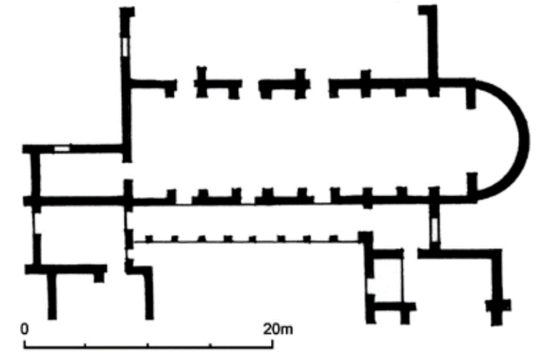
As Christianity was becoming more popular churches become public institutes. It became an organized establishment where people bring offerings to deacons who serve there on regular basis. [5]
Linear rectangular layout especially in the east part of the world become the new trend. Aisles become more defined by floor patterns. Natural light is introduced to the interior. [5]
Fig 2 S. Julianus, Umm al Jamal 345, after Butler, 1969: 18, ill. 11

Source: S. Balderstone, “Early Church Architectural Forms”, page 6

The Basilica Church

Probably the most influential type, the Basilica has been used as a foundation for church design since the beginning of the 4th century. The establishment of Christianity as a state religion in the west make the establishment of public churches prominent. The basilic of the roman empire from the past become the inspiration for the design approach of churches.
Architecture become interlocked with religious believes. Interpretation of biblical verses by spaces and material become the core of church buildings. “Path”, the concept of a person's journey to his soul and meaning of life, molded the linear arrangement of the basilica. The longitudinal axis representing the path of life crossed by a vertical axis of salvation creating a central space where God is revealed was the main principle of the design.[6]
The apse for the Altar was small, so Bema was introduced to hold more clergy. This shaped the rectangular layout into a T-shaped one. Then a further expansion of the Dias to the east gives it a cross shape interior space which become to be known as “Latin cross layout”. [6]
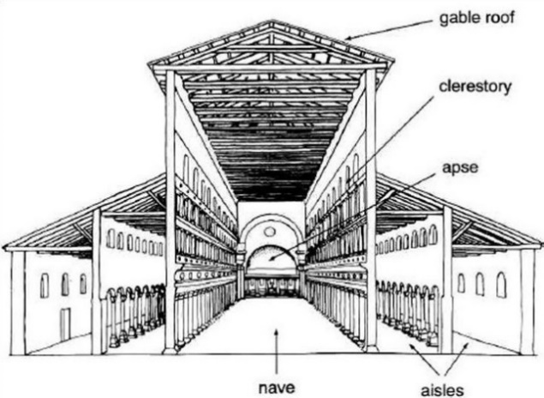
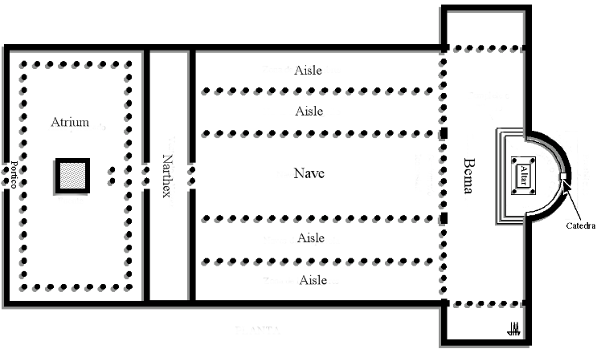
The longitudinal part was divided horizontally by columns creating a Nave in the middle and aisles on each side. The number of aisles varies from one church to another. Most of them have 1,3 or 5 aisle spaces. Some churches build paradise court in Infront of the basilica to emphasize the entrance.
a
b
Source: https://en.wikipedia.org/wiki/Church_architecture

Fig 3 Old St Peter's Basilica. A) Plan b)3d cross section
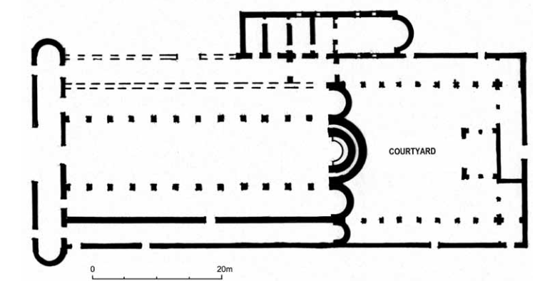
In some cases, the designing of the apse becomes more complex as what used to be a simple Dias in front of the nave is now complemented by a parallelly placed smaller apse next to it. Some in semicircular and others in polygon arrangement. Also, the space behind the apse is distinguished as a place for holy tombs and monasteries. Some even have a courtyard in between the apse and the holy tomb-like in the case of the basilica of Campanopetra, salamis-Cyprus.[5][2]
Source: S. Balderstone, “Early Church Architectural Forms”, page 33
Fig 4 Plan of Campanopetra Basilica, Salamis 5th-6th C, 1980

Eastern Orthodox Church

The shift of the roman empire into the east in the 5th C bring the separation of Christianity into western catholic and eastern orthodox churches. The linear layout of churches evolves to a centralized, compact space in the shape of a ‘Greek cross’. The interior is usually circular, square, or octagonal. The transept, apse, and nave are located at the same distance from the central space, which is covered by, a physical metaphor of heaven, a dome. The domes usually have openings. The interior was decorated with mosaics of holy pictures. The vestibule/ narthex was given more emphasis. [6]
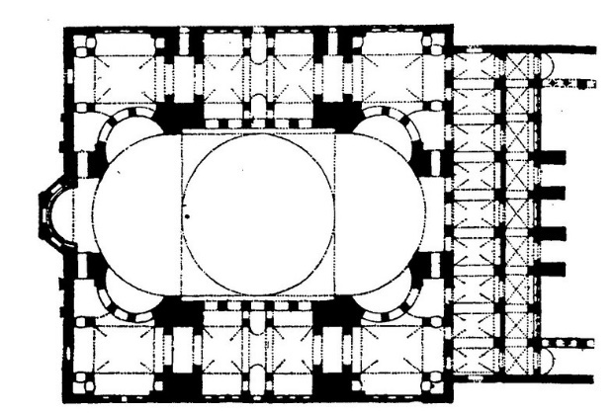
The first centralized church was Mausoleum_ Santa Costanza. Mausoleum and temples were converted to churches. This was the case for the Pantheon temple of Rome. After the 6th Ad, some churches integrated a centralized layout with a basilica [6]

a
b
Fig 5: Hagia Sophia (Aya Sophia) in Constantinople (Istanbul, Turkey). 537 AD a) Plan b) cross-section
Source: https://izzyziskind.hosting.nyu.edu/daraa_izzy/hagia-sophia-justinian-i-537/

Romanesque

“Descended from Roman” as the name describes it’s a derivation of a Roman basilica with a fusion of eastern centralized churches which happen from the 10th century up to the Gothic period in 12th c. Monasticism was the main reason for the origin of this trend as materialism is sunken given more emphasis on the spiritual essence of space can bring.[7]
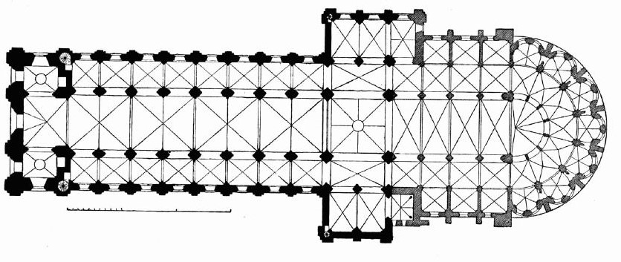
Heavy, decorated masonry interior walls with small openings become the dominant factor. Semicircular roofs supported by stone barrel vaults complement the verticality of the nave. A tall tower with pointed arches in the connecting point of nave and transept with smaller ones in the west sides. The decoration is simple grooving of zigzag or spiral in the native material. [7]
Fig 6 Plan of Saint-Étienne, France, 12th c

Source: https://www.pinterest.com/pin/16677461093871466/

Gothic

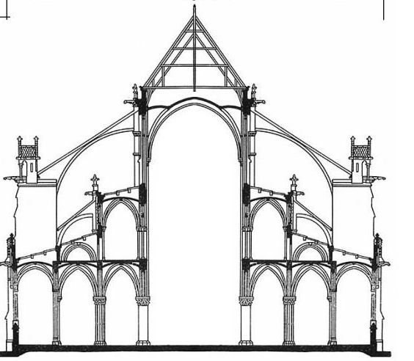
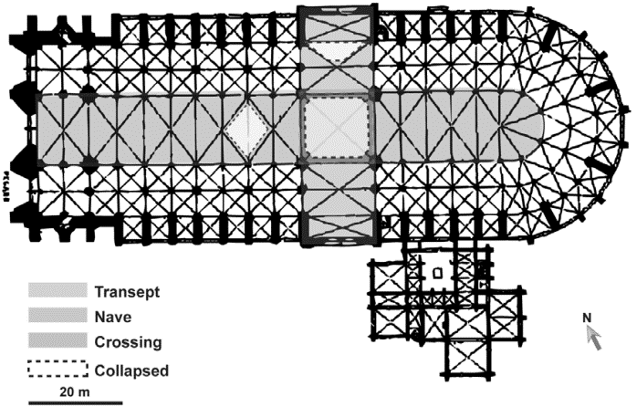
In mid of the 12th c after the Romanesque period romanticizing of space with light and decoration was added to church architecture. Even though the planar layout did not change from the previous period, the walls become lighter and thinner, leaving space for lightweight vaults and large stained-glass openings. The structure innovation of transferring load using flying buttress and pointed arches were the major character of the time.[6], [8]
Source: Vannucci. “A nonlinear approach to the wind strength of Gothic Cathedrals”, page 5
b
a
Fig 7 Cathedral of Notre-Dame in Paris,1163 – 1345 a) plan b) Cross-section

Renaissance
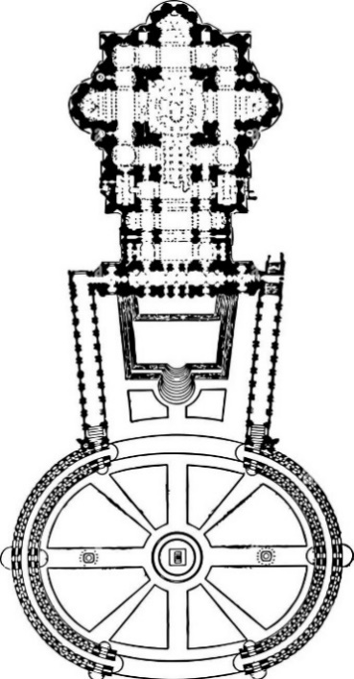
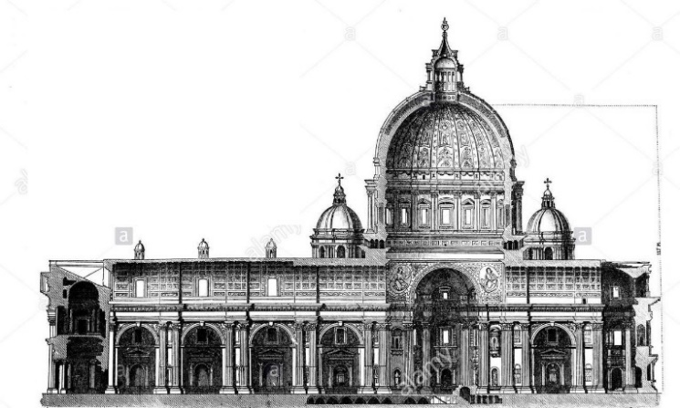
The word renaissance means “rebirth” which was between the 14th – middle of the 16th c. It is the revival and refinement of roman architecture. The style places emphasis on symmetry, proportion, geometry, and the regularity of parts, as they are demonstrated in the architecture of classical Romans and Greeks. Rows of cylindrical columns with Corinthian capitals, semicircular arches, apsidal chapels, entablature were reintroduced. [9]

b
a
Fig 8 Peter's church, Rome. the forum was built in the later stage of the renaissance (Baroque) a) Plan b) Cross-section
Source:https://etc.usf.edu/clipart/73400/73439/73439_st_peters.htm , http://www.greatbuildings.com/buildings/st_peters_of_rome.html

Baroque

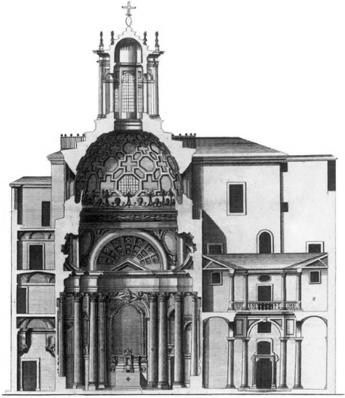
From 16th-18th c experimentation on forms and layout of churches took place in the name of “Mis shape pearl” or “Baroque”. The dynamic play of interior spaces and facades with complex architectural plans becomes the norm. Vividly painted ceiling, twisting elements, and contrast with light dramatized the feeling of the space. The altars were higher with the dome extended above them. The use of convex & concave was amplified in the forms and plans. The late stage of the Baroque style become known as Rococo, where churches become more decorative and non-architectural elements like luxurious cloths and fabrics dominate the religious ceremonies.[10]–[11]
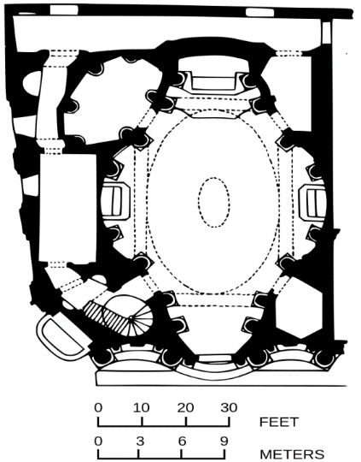

a
b
Fig 9 San Carlo alle Quattro Fontane, Rome a) Plan b) Cross-section
Source:https://en.wikipedia.org/wiki/San_Carlo_alle_Quattro_Fontane

Eclecticism

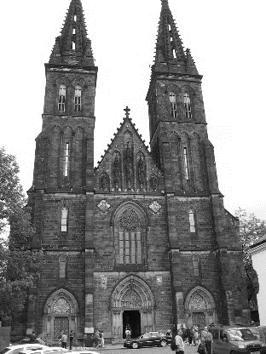
This period of church design is characterized by the harmonized mixture of the previous architectural trends to create a unique church style. This eclectic idea is mainly incorporated in the interior, structure, furniture, façade, and architecture of the building. The most dominant style revived and adopted in this period were Gothic period churches, labeled as Neo-gothic churches. Their elegancy was catalyzed by incorporating them with other revived architectural styles. 19th – 20th C was a time of freedom in choosing the past techniques to develop something exquisite Architecture. [13], [14][15]
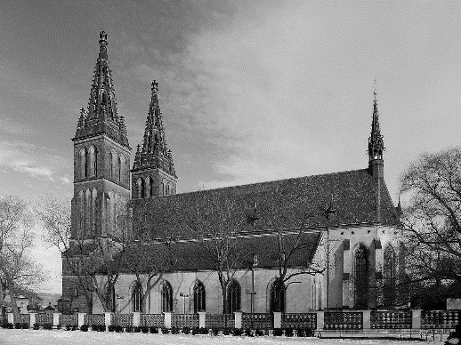

b
Fig 10 Basilica of St. Peter and St. Paul, Prague a) Picture from the side b) Picture from the front side
Source:https://en.wikipedia.org/wiki/Basilica_of_St._Peter_and_St._Paul,_Prague

a

Modern

The idea of a worship place should not be corporate rather a single functional hall for purpose of worship emerged in the 20th c movement, called Modernism. The design of churches becomes the subjective expression of Architects rather than an objective manifestation of biblical meanings.[6]
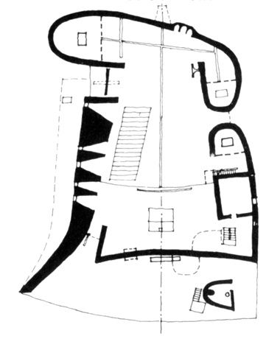
“Less is more” the ideology of simplicity and purity of modernism tried to be attained in the design of churches by using clear reinforced concretes with glasses. The building stripped down into its pure functional aspect with the abstractive expression of forms.[6]

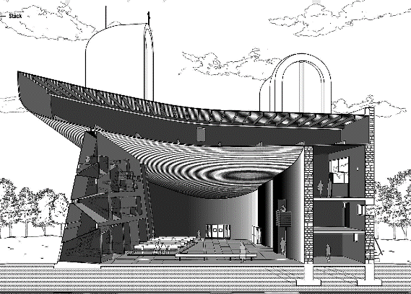

Source: https://www.pinterest.com/pin/621496817309996915/

Fig 11 Neuterd de Roschamp church, Le Corbusier, france,1954 a) Plan b) Sectional 3D

a
b

Post-Modern
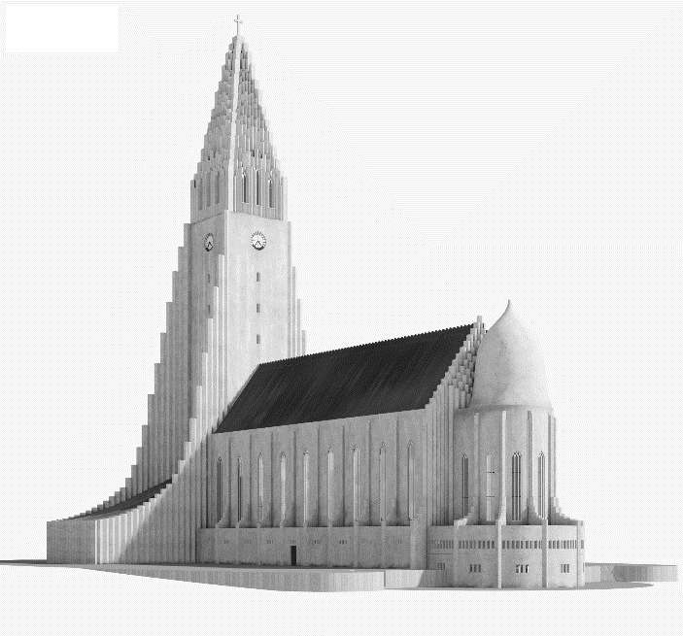
In the 2nd half of 20th C while following the same principle as modernism the utopianism and boldness of design in churches revolted by the motive “less is bore”.[16] The new movement wants to attach religious and cultural soul in church buildings while following the principle.
The postmodern focused on context and attaching historical elements into the plain configuration of modern designs. Pitched roof replaced flat roof, solid material dominates the once glass covered wall surface and the blueprint become highly spirited. [6]
Source: https://hum3d.com/3d-models/hallgrimskirkja/

Fig 12 3D visualization of Hallgrimskirkja church, Reykjavik, Iceland,1937-1986

Basic typological principles, typological characterization

The concept of categorizing church is mainly dependent on the functional layout of the interior spaces. Forms and figures of the church have changed since the beginning of its time, as they become the picture of every architectural philosophy throughout history. Their major functional essence which was explained in the basic concept of the church above is the only thing standing firm, even in the time of hardship for the core existence of them. In the 20th C, the subjective design approach influences their true space ergonometric. Yet it is still on the premise of the fundamentals of church organization.
In this essay, we will see two different major layouts which have been used and still is influential in the design of churches in Europe: -
- The Western Roman Catholic Church
- The Eastern Orthodox Church

The Western Roman Catholic Church Type

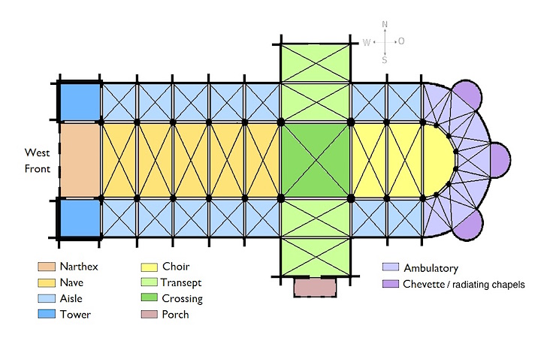
The basilica, adapted from Roman temples and buildings, is a rectangular hall with a semi-circular end on the east. They are the basic layout inspiration for the Cathedral. The Cathedral church evolved through time from the simple nave church into a more sophisticated Latin cross church. This is because of the continuous necessity of evolving and expanding spaces needed for worship and religious ritual. Their symmetrical longitudinal layout with a focal point in the east of the building unifies them. [17]
Source: https://courses.lumenlearning.com/suny-arthistory1/chapter/church-architecture/

Fig 13 Basic layout & terminology of Basilica church floor plan

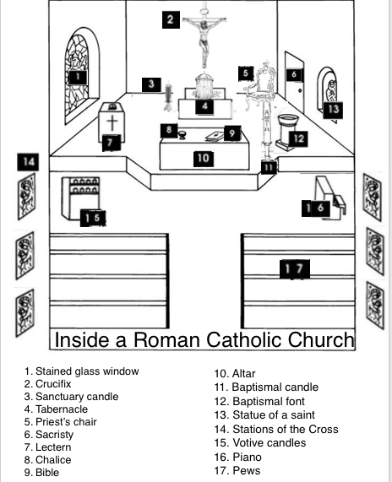
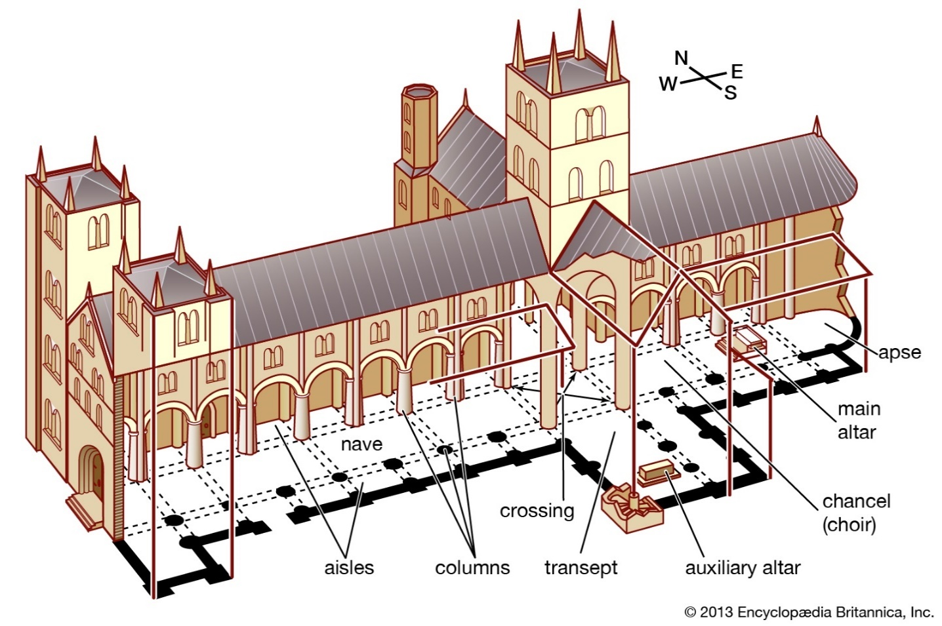
The worshippers enter from the west, sitting in the nave or some portion of aisles. The altar for the bread and wine is placed on the east side, Apse. Later, Bema is introduced to hold as many clergies as possible. The transept crossing the main axis gives it an appearance of a “Latin cross” layout, separating the apse from the rest of the space. Atrium or courtyard is planned in some churches to emphasize the entrance hall. The narthex distinguishes those who are not allowed to be admitted to the general congregation. The ceiling height of the nave is higher than the one at the apse. The initial gable roof was later complemented by domes.
Source: https://www.britannica.com/topic/church-architecture

Fig 15 Inside Roman Catholic Church 3d illustration
Fig 14 Sectional 3D representation of Roman Catholic Church layout & Terminologies

An alternative to the basilica church can be seen in the picture below with an additive, subtractive, and modification of the basic space arrangement. [18]Different typologies can be seen which were derived from the basilica by
- Inserting atrium in the west side
- increasing the number of aisles from 2 up to 6
- using of more than one apse and extending the area beyond them
- extending the width of the interior space and
- peripheral wall imitating the semicircular shape of the apse
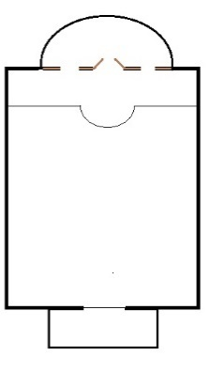
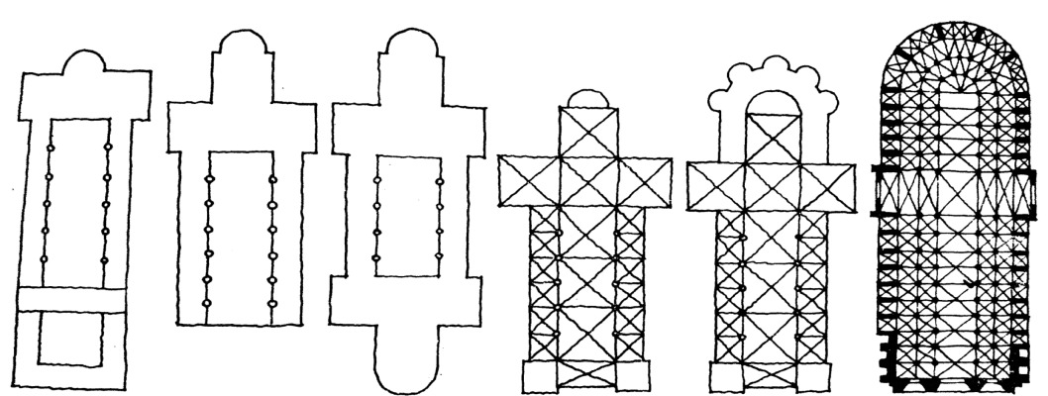
Fig 16 Variation of the Basilica Church layout b-Nave church, a-Old Basilica, c, Pre Romanesque, d-Romanesque, e-Gothic cathedral
e
d
c
b
a
Source: Klara Frolíková È Romanesque ArchitectureÈ. Page 16

The Eastern Orthodox church type

The other major church typology is the one that evolves from the design of mausoleums in the eastern part of Europe. It is a concentric layout with two major shapes square or a circle. The ritual which takes place in the orthodox church is different from the cathedrals of the westerns. Major emphasis is given to the crossing where the dome is placed. The altar below the dome. The Ambulatory in this case is a sitting place for the followers.
Three or two circles are formed by columns surrounding the altar to create a hierarchy of classes. The clergy and bishops stay in the middle of the ceremony.
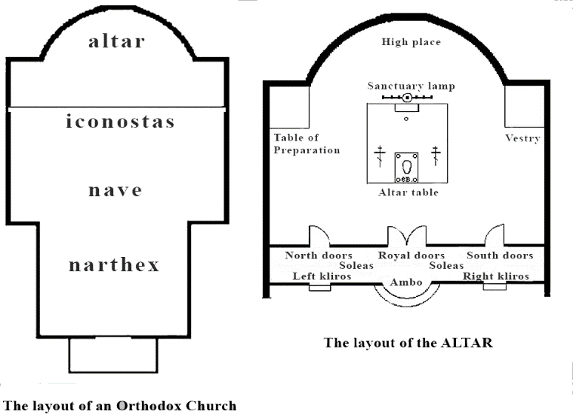
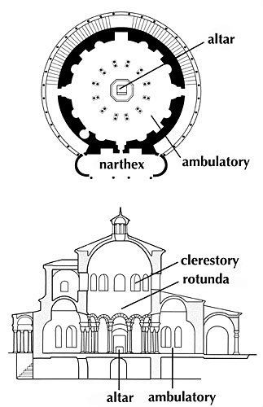
Source: https://slideplayer.com/slide/4362773/ ,Slide 24

Source:https://www.stgeorgeparish.org.au/information/1029/1034/

Fig 17 Planar illustration of Orthodox Church type
b
a
Fig 18 Eastern Orthodox church layout a) Plan b) Cross-section
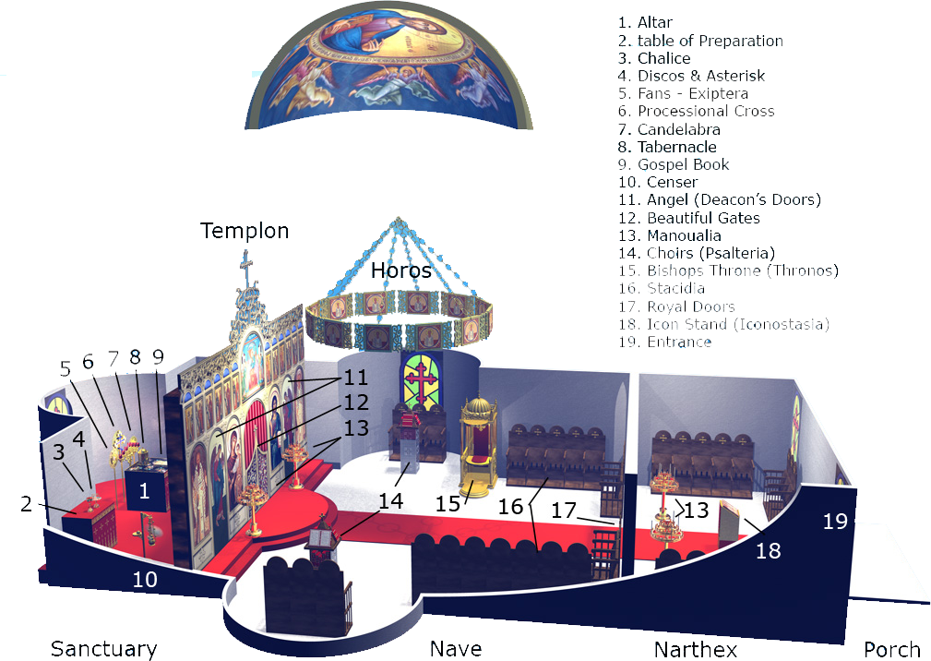
Source:https://en.wikipedia.org/wiki/Eastern_Orthodox_church_architecture

Fig 19 Sectional 3D representation of Orthodox Church layout & Terminologies
“Greek-Cross” describe the mutated layout of the circular church, which extended its arm equally from the crossing. It is more secular than the basilica layout. The religious practice takes place in the sanctuary closed by a curtain.
The orthodox church has different variations. Some of them are
- cross in square
- cruciform and
- a composite of two with the basilica
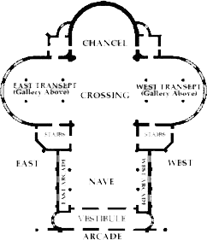
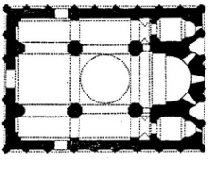
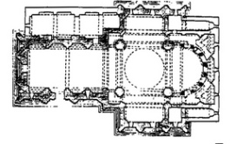

a
Source:https://en.wikipedia.org/wiki/Eastern_Orthodox_church_architecture

Fig 20 Variation of Orthodox centralized churches a) Cross in square b) Cruciform c) Composite
b
c

The current situation in the Czech Republic and Europe

Christianity is fading from Europe. Once the dominant religion in the continent is now overshadowed by atheists. Society is no longer culturally influenced by beliefs. Thus, in the 21st c, the number of churches that are being built is very seldom. Once a place for socializing and worshiping now become abandoned areas. Some even change their function to another demoralizing one according to the followers.[19]
In Czech, the existence of churches is at stake as 91% of the population aged between 16-29 have no religion which is more than any other country in Europe. More than a hundred churches are ruined with no maintenance. [19]Even those who still serve the faithful have a handful number of people using them. The only church (church of Christ the savior) built-in Prague since the last decade shows the severe condition of the church futurity.[20]

Realization examples in the Czech Republic

St. Barbora, Kutná Hora, Czech Republic
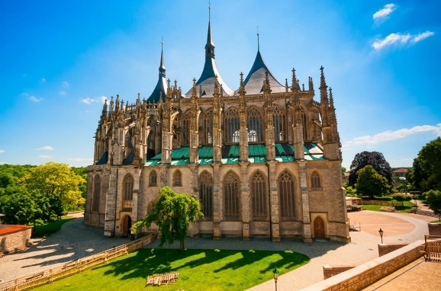
Designed by Architect Johann Parler,1359 – 1405/06
Fig 21 St. Barbora church, Kutná Hora
Registered in UNESCO heritage site list, this Gothic masterpiece has a basilica church layout. The construction period Span from 1388-1905. It has gone through the influence of the Renaissance and Baroque style in its interior. The stained glass is completed in the neo-gothic renewal stage in 20th C with the help of the donors. Thus, this church is a good example of a basilica church going through different architectural eras without losing its functional aspect. [21]
Source: https://it.tripadvisor.ch/

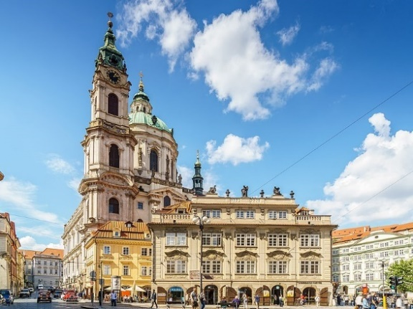

St. Nicholas Church, Mala Strana, Prague
Designed by- Architect Giovanni Domenico Orsi,1634 – 1679
A great example of Baroque. St. Nicholas was built in 1704-1755. It was built over a gothic church which was built on the 13th C. The dome is 70m high and 20m diameter decorated with paintings and sculptures. It has a composite layout of a basilica with an Eastern orthodox church. Even though it has one common Architectural style, Its functional layout is a mix of both.[22]
Source:https://commons.wikimedia.org/wiki/File:Prague_Mala_Strana_St._Nicholas-02.jpg

Fig 22 St. Nicholas Church,Prague
Church of Beatified Restituta, Brno, Czech Republic
Designed by Architect Atelier Štepán. Brno, Czech Republic
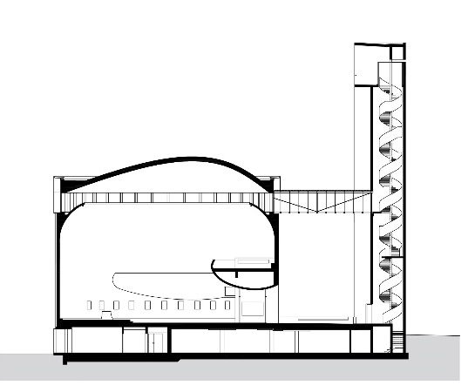
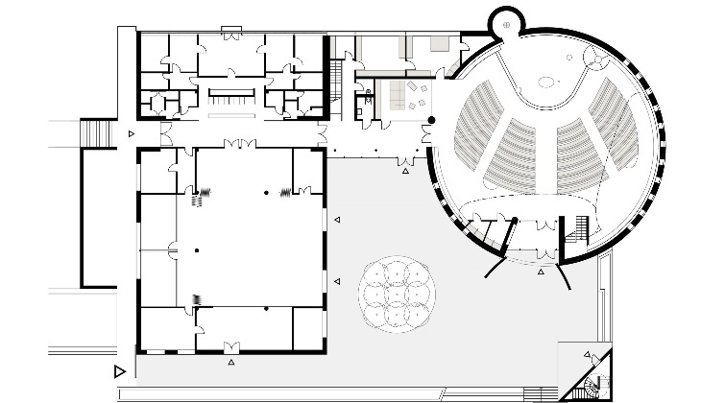
The church is a depiction of modernism where the elements are stripped down to the bare minimum. It is designed by Atelier Štěpán for the completion of the housing project proposed by Zdeněk Bureš in the 1960s. "The question of the perception of a church is a question of the contemporary perception of the world." Marek Štěpán. Thus he makes a contemporary church in the middle of the apartment blocks as a unifying element. It is the expansion of the existing spiritual place made in baroque style. [23]

Source:https://www.archdaily.com/947598/church-of-beatified-restituta-atelier-stepan

Fig 23 Church of Beatified Restituta a) Plan b) Cross-section
b
a

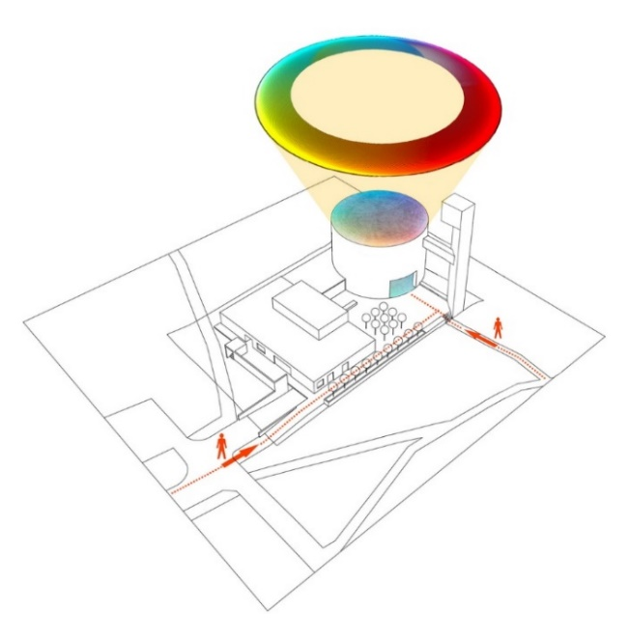
It has a circular hall connected by a bridge with a triangular concrete made tower. The clear concrete wall has a stained glass window spanning 80m in the top. These windows create a rich light illuminating the dome ceiling. It has two curvaceous balconies for sitting places for the faithful and choirs. The tower is hanging up to an enticing view of the city of Brno. And connected to the main building through a corridor to the upper floor of the museum.[23]
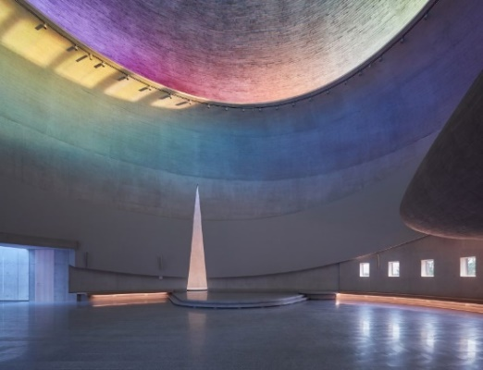
The church has all three basic shapes triangle, circle, and rectangular connected in harmony with one another. The windows on the halls are small rectangular ones bursting from the thick concrete wall. The entrance which leads to the 1st-floor breaks the auditorium.[23]

Fig 24 Church of Beatified Restituta a) Illustration of the concept b) Interior view
Source:https://www.archdaily.com/947598/church-of-beatified-restituta-atelier-stepan

b
a

Reference

[1] Parr, A. “Church History EXPLAINED in FIFTEEN MINUTES! | A.D. 33 - PRESENT.” [Online]. Youtube, The BEAT, (accessed Dec. 05, 2021). Access: https://www.youtube.com/watch?v=Mnq_kiQicnE
[2] Cole, E. “A concise history of architectural styles.”, Ostrava: Gardners Books, 2003,p. 352.
[3] Shekhar, K. “The Concept of the Church in Christianity,” Imp. J. o Interdiscip. Research, 2017, vol. 3, no. 2, pp. 1227–1230.
[4] Peppard, M. “Chapter Title: Dura-Europos and the World’s Oldest Church Book Title: The World’s Oldest Church Book Subtitle: Bible, Art, and Ritual at Dura-Europos, Syria.” [Online].Yale University, press,2016. Available: Dura-Europos and the World’s Oldest Church from The World's Oldest Church: Bible, Art, and Ritual at Dura-Europos, Syria on JSTOR
[5] Balderstone, S. Early Church Architectural Forms, Title: A Theologically Contextual Typology for the Eastern Churches of the 4th-6th Centuries, 2007. Buried History Monograph No. 3: Australian Institute of Archaeology, Melbourne. 2007, no. 3.
[6] “Church architecture ” [Online]- Wikipedia.org 2021. (accessed Oct. 25, 2021) . Access: https://en.wikipedia.org/wiki/Church_architecture
[7] “Romanesque architecture” [Online] Britannica.com. (accessed Dec. 02, 2021). Access: https://www.britannica.com/art/Romanesque-architecture
[8] Ching, F. “Visual Dictionary of Architecture ” Addis Ababa, 2016, pp. 165–190.
[9] Woods, J. “Gothic Architecture,” Lett. an Archit. from Fr. Italy Greece, 2014, pp. 29–43, ISBN: 10.1017/cbo9781107252875.004.
[10] “Baroque architecture” [Online] Britannica.com. (accessed Nov. 11, 2021). Access: https://www.britannica.com/art/Baroque-architecture
[11] “Baroque architecture.” [Online]- Wikipedia.org 2021. (accessed Dec. 05, 2021) . Access: https://en.wikipedia.org/wiki/Baroque_architecture
[12] “Church Anatomy” [Online] Essential Humanities.net (accessed Nov. 25, 2021).Access: http://www.essential-humanities.net/art-supplementary/church-anatomy/
[13] Eclecticism in architecture.
[14] “Eclecticism in architecture.” [Online] Wikipedia.org 2021. (accessed Dec. 05, 2021) . Access: https://en.wikipedia.org/wiki/Eclecticism_in_architecture
[15] Mansbridge, j. “Graphic History of Architecture.” Hennessey & Ingalls. 1999, pp. 50–60
[16] “Less is a Bore book celebrates ‘postmodern architecture in all its forms.” [Online]dezeen.com (accessed Dec. 05, 2021). Access: https://www.dezeen.com/2020/02/14/less-bore-book-celebrates-postmodern-architecture-forms/
[17] “Architecture of cathedrals and great churches.” [Online]- Wikipedia.org 2021. (accessed Dec. 01, 2021) . Access: https://en.wikipedia.org/wiki/Architecture_of_cathedrals_and_great_churches
[18] Carlson, E. G. and Kubach, H. E. “Romanesque Architecture,” Art Bull, 1977, vol. 59, no. 2, p. 269, ISBN: 10.2307/3049642.
[19] “Does Christianity still have a place in modern Europe? - YouTube.” [Online]. Youtube.com. Roundtable, (accessed Dec. 05, 2021). Access: https://www.youtube.com/watch?v=F_JCZZyMTEM

[20] “New church building, Prague’s first in 10 years” [Online]- expats.CZ ,Prague, Czech Republic. (accessed Dec. 05, 2021). Access: https://www.expats.cz/czech-news/article/new-church-building-prague-s-first-in-10-years-consecrated-in-barrandov-today
[21] “St. Barbara’s Church, Kutná Hora” [Online]- Wikipedia.org 2021. (accessed Noc. 29, 2021) . Access: https://en.wikipedia.org/wiki/St._Barbara%27s_Church,_Kutná_Hora
[22] “St. Nicholas Church (Malá Strana)” [Online]- Wikipedia.org 2021. (accessed Dec. 05, 2021) . Access: https://en.wikipedia.org/wiki/St._Nicholas_Church_(Malá_Strana)
[23] “Atelier Štěpán tops circular church with a rainbow stained-glass window.” [Online]dezeen.com (accessed Dec. 02, 2021). Access: https://www.dezeen.com/2020/09/20/atelier-stepan-church-of-beatified-restituta-rainbow-stained-glass/

Index
A
Aisles_' a passage between rows of seats in a church', 4
Altar_' table where sacramental bread & wine is placed', 5, 13
Apse_' a structure which radiates tangentially from the bays ', 5, 6
B
Basilica_'large long hall with double colonnade for gathering', 0, 1, 5
Bema_ ' a raised dais or platform which hold more than one person, 5
D
Dias_'a raised platform in front of a hall or a room', 4, 5
E
Entablature_'superstructure of molding placed horizontally above columns', 7
M
Mausoleum_' a free-standing structure for housing a tomb or group of tombs', 6
N
Nave_'central part of a building for holding congregation', 5, 6
S
Synagogue_' a place for gathering', 4
V
Vestibule/ Narthex_' a void space located in the entrance of a building', 6

