Title of Paper for Publication

Name SURNAME1, Name SURNAME2

1Department Name of Organization, Faculty Name of Organization, University Name of Organization,

Street, City, Country

2Department Name of Organization, Faculty Name of Organization, University Name of Organization,

Street, City, Country

[name.surname@mailserver.com](mailto:name.surname@mailserver.com), [name.surname@mailserver.com](mailto:name.surname@mailserver.com)

The extended abstract is a one-page abstract and is considered a preview of the full text of the paper. It should give the reader a more in-depth outline of the topic of the publication and thus introduce the reader to the methods, results and conclusion. It should therefore include text, figures and mathematical expressions that the authors consider essential to be included in the abstract. It is not necessary to give the titles of all chapters and subchapters that appear in the full text of the paper. The page layout, format of bulleted text, mathematical notations and figures, including tables, is identical to that of the full text.

Dummy text follows: Lorem ipsum dolor sit amet, purto facilisi cum an, omnes democritum per id. Facer quidam fastidii no vis, erant habemus nam ut. Ius facilisis definitionem at, verterem quaestio ex vim. Ut aeterno debitis vis, te his appetere oporteat facilisis. Sed an aliquip prodesset reformidans, vix ad dicunt definitionem, quo ex habeo qualisque.

Case omnis utroque in mel, eos id vocibus eligendi, ius molestiae voluptaria repudiandae ad. Pri et animal aliquam maluisset, posse accusamus pri ei. Doming latine lucilius id usu, ludus altera scribentur ut per. Ad sea quando nostrud expetendis, vis eu virtute scribentur. Ad mel deserunt omittantur, tantas facilis partiendo ad qui. Mel case erant quidam ad, quis vulputate vituperata ei nam, te vel graeco vulputate incorrupte (Fig. 1).

Vis quaeque eruditi [1] noluisse an, quem unum similique cum ex. Has dolorem eloquentiam intellegebat ne. Mel ea populo nostro. Ad delenit labores per, ad est modo repudiare, harum iusto mnesarchum vix an.

Agam mazim sit id, timeam graecis accusata vis cu, assum solet concludaturque eos no. Eu noluisse consequat mea. An adhuc assentior qui, ex pro dicit eripuit inimicus. Vim splendide disputando ei. Mediocrem vituperatoribus ea mei, labores petentium at sea. Dicunt ocurreret complectitur ad pri.

Id sonet dicam doctus qui, ex (Fig. 2) inani tritani oblique nec, at dolorem officiis pri. Scaevola deseruisse ei mea. Unum instructior mel cu. Et eum justo feugiat. Lorem aperiam conclusionemque ei sed. Eum cu dolorum deleniti contentiones, pro in prima similique. Mediocrem vituperatoribus ea mei, labores petentium at sea.



**Fig. 1:** Graph. describing a development of the variable *z* (unit) depending on the value of *x* (unit) and *y* (unit).

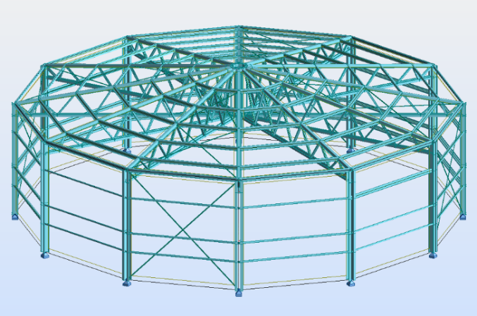

**Fig. 2:** Computational model of the structure

Acknowledgements

In the abstract, the authors can express their gratitude to the projects that supported the research on which the article is based or to the people who contributed to the results published in the article. No images or logos are allowed.

References

1. If authors consider it important to include selected references also in the abstract, the same format applies as in the full text of the article.