Transactions of the VŠB – Technical University of Ostrava
Civil Engineering Series, Vol. 17, No. 2, 2017
paper #??
Name SURNAME, Name SURNAME
Contribution Title In English
Abstract
Recommended length of the abstract is 5 lines. The abstract must be prepared according to ISO 214 standard. Abstract is a short characterization of the work which describes what about the publication is given, but not presents results or new knowledge.
Keywords
Here you can specify a list of keywords of your paper - the essential terms publications, which are separated by commas. Correctly chosen keywords make it easier to find work in library systems and databases.

1 Introduction
Introduction shows the reader to the publication and it is already organic part of the content of the work. Introduction usually presents a wider context, of which are based whole of publication. Often includes a specification of the conclusion. Introduction allows, for example in relation with a description of the broader context and the current state of knowledge in this area, to publish a number of bibliographic citations and sources.

2 Brief description of the journal
Transactions of the VŠB – Technical University of Ostrava, Civil Engineering Series, is a long-term publishing of printed matter of Faculty of Civil Engineering, VŠB - Technical University Ostrava. Transactions of the VŠB – Technical University of Ostrava, Civil Engineering Series, provide space for publishing shorter original posts in the focus of scientific research and engineering activities of Faculty of Civil Engineering, VŠB - Technical University Ostrava. It also offers publishing opportunities for professionals in equivalent fields at other universities, companies, research, science and related institutions in the Czech Republic and abroad.
All submissions are reviewed by two assessors in the field, who must be from another department (institution, faculty) than the author and co-authors.
Transactions of the VŠB – Technical University of Ostrava, Civil Engineering Series, is a member of the List of non-impacted reviewed periodicals published in the Czech Republic. The list is established by Council for the research and development of the Government of Czech Republic.

2.1 The scope of published articles
Published articles intended for on-line version of the Transactions of the VŠB - Technical University of Ostrava, Civil Engineering Series, in electronic form are not limited in scope.

3 FORMAL REQUIREMENTS THE PREPARATION OF PAPER
Format contribution is defined by the template that is used for creating papers in Transactions of the VŠB – Technical University of Ostrava, Civil Engineering Series. The basic page layout matches the format of B5 (width = 176 mm, height = 250 mm) with the following mirror edges: bottom = 18 mm, left, right and top = 16 mm.
Basic font of article is Times New Roman. All text paragraphs consists font size of 10 points, chapter titles size of 11 points are bold. The titles of the main chapters are written using upper case. Everything is pre-defined in paragraph style. Do not change the predefined styles!
Professional publications should be kept in "impersonal" style.

3.1 Format of formulas and arithmetic expressions
The formulas in the article are placed on a separate line. The sample form looks like this:
(1)
where:
V_{z} – is shear force in cross-section [kN],
– is static moment „separated“ part of cross-section [m³],
I_{y} – moment of inertia of whole cross-section [m⁴] and
– width of cross-section in selected fiber [m].
Using the formula and the reference to them must respect the rules for formatting, which are given in standard ISO 80000 with general information on the principles relating to the publishing of physical variables, equations, symbols for quantities and units and coherent system of units, in particular the International System of Units SI.
It is necessary to observe the following fonts for selected parts of arithmetic expressions:
- Mathematical signs of variables ​​- italics,
- Numbers, constants – upright fonts,
- Explicitly defined functions - upright fonts,
- Exactly defined operators, such as the differential on equation (2) – upright fonts,
Units – upright fonts.
Here is another example of the arithmetic formula:
(2)

3.2 Inserting images into text
Another example of an exemplary published image is on figure 1, which is always in the middle of the page. His description is given under each picture.
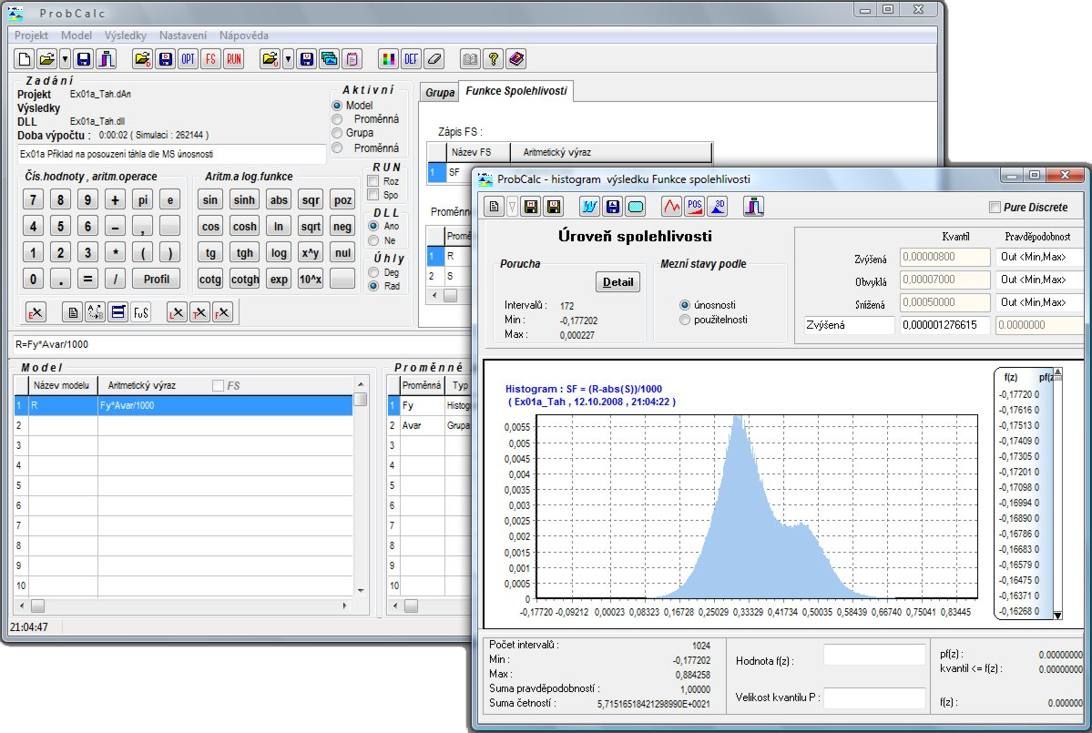
Fig.1: Title of the picture is Desktop of the ProbCalc code

3.3 Bullets
The text with bullets may also be presented indent by the following examples:
1. bullet,
2. bullet.
To be numbered paragraph, the final design looks like this:
numbered paragraph,
numbered paragraph.

3.4 Tables
Another example contains an exemplary published table that is aligned to the left. Its width should not exceed the width of the paragraph 144 mm. Its description is given above each table.
Tab.1: The table title
Variable | Type of distribution | Parameters
 |  | Mean value | Standard deviation
The amplitude of stress peaks Δσ [MPa] | Normal | 30 | 2

4 bibliographical references
Bibliographic citations are a summary of all material information about the sources from which they were selected interesting ideas, which are significantly associated with text or illustrate their relationship.

Bibliography (list of bibliographic citations) states in the interest of the reader, who then may not:
- laboriously search where these ideas come from,
- doubt about the correct authorship of each section of the text,
- spend time searching for what might still interesting to read the topic.
All cited works and references must be included in the reference list and vice versa. Bibliography can be arranged alphabetically and chronologically by the author or numeric sequence, which corresponds to the order of links in the text. In the text itself it is possible to refer to the item list in the form of brief bibliographic citation at the appropriate place in the text: either the number of publications listed in square brackets, or directly to the author's name and the year (usually in brackets).
Citations in the bibliography at the end of the article should respect the rules defined in the standard ISO 690 (01 0197). In citations is not enough to cite only the weblink - citation online also has its rules.
Ensure quality citation of impacted sources (database Scopus and Web of Science), restrict citation of standardized rules. Cite your previous publications and works of colleagues from your focused area, which has been published in Transactions of the VŠB – Technical University of Ostrava, Civil Engineering Series. Prefer citations of articles in on-line version of Transactions of the VŠB – Technical University of Ostrava, Civil Engineering Series, (http://www.degruyter.com/view/j/tvsb), e.g. [4].

5 Paper application
Application form for the publication of an article in the current issue Transactions of the VŠB – Technical University of Ostrava, Civil Engineering Series, is listed on the website Faculty of Civil Engineering, VŠB - Technical University Ostrava. The application is required, among other things, the proposal of two expert reviewers in the field, who must be from another department (institution or faculty) than the author and co-authors.
Without fully and correctly completed application form will not be accepted by the Editorial Board contribution to the review process.
Editorial Board of Transactions of the VŠB – Technical University of Ostrava, Civil Engineering Series, assesses registered papers, decides on their substantive and formal content, editing and graphic attachments. Specifies the opponents of individual contributions, but may take into account the proposal reviewers, which the author suggests in the application form. Editors reserve the right to edit articles and graphics, to comply with graphic journal format.
Editorial board provides the communication with reviewers and notification with the resulting reviewer's opinions to the author (in case of multiple authors the editorial board corresponds with the main author mentioned in the application).
If the main author of the paper (listed first) is doctoral student, it is required to deliver to editorial board the written recommendation of the supervisor with agreement to publish this article. In the case of an external Ph.D. student is to be noted that it is his duty to publish under the name of the relevant department and not under the company where he is employed.

6 Conclusions
A conclusion for professional the work summarizes the main results. Often brings challenges for the future. Conclusion corresponds with the introduction - introduction defines the goal of the work, the conclusion describes the fulfillment of this goal. Outlook for the future in terms of research work allows in the conclusions provide additional resources and bibliographic citations again.

acknowledgment
If the article has been funded with support, can give such notice as follows: The paper has been supported by the project of “Conceptual development of science and research activities 2016” on the Faculty of Civil Engineering, VŠB-TU Ostrava.
LiteraturE
AUTHOR, A. B. Publication title. 1st ed. Praha : SNTL, 1995. 250 pp. ISBN 1-234-568-787.
AUTHOR, C. & AUTHOR D. Contribution title. Journal name. 2005, XXVI. Nr. 2, pp. 56-58. ISSN 1234-5678.
AUTHOR, E. Paper title. In Proceedings name. Place : Company name, 1989, pp. 156-158. ISBN 12-34-567-89.
AUTHOR, A. Paper title. Transactions of the VŠB – Technical University of Ostrava, Civil Engineering Series. Volume 15, Issue 1, Pages 1–10, ISSN (Online) 1804-4824, DOI: 10.1515/tvsb-2015-0001, July 2015.

Assoc. Prof. Ing. Name Surname, Ph.D., Department of Structural Mechanics, Faculty of Civil Engineering, VŠB - Technical University Ostrava, Ludvíka Podéště 1875/17, 708 33 Ostrava - Poruba, Czech Republic, phone: (+420) 597 321 313, e-mail: name.surname@vsb.cz.
Ing. Name Surname, Ph.D., Department of Building Structures, Faculty of Civil Engineering, VŠB - Technical University Ostrava, Ludvíka Podéště 1875/17, 708 33 Ostrava - Poruba, Czech Republic, phone: (+420) 597 321 313, e-mail: name.surname@vsb.cz.

